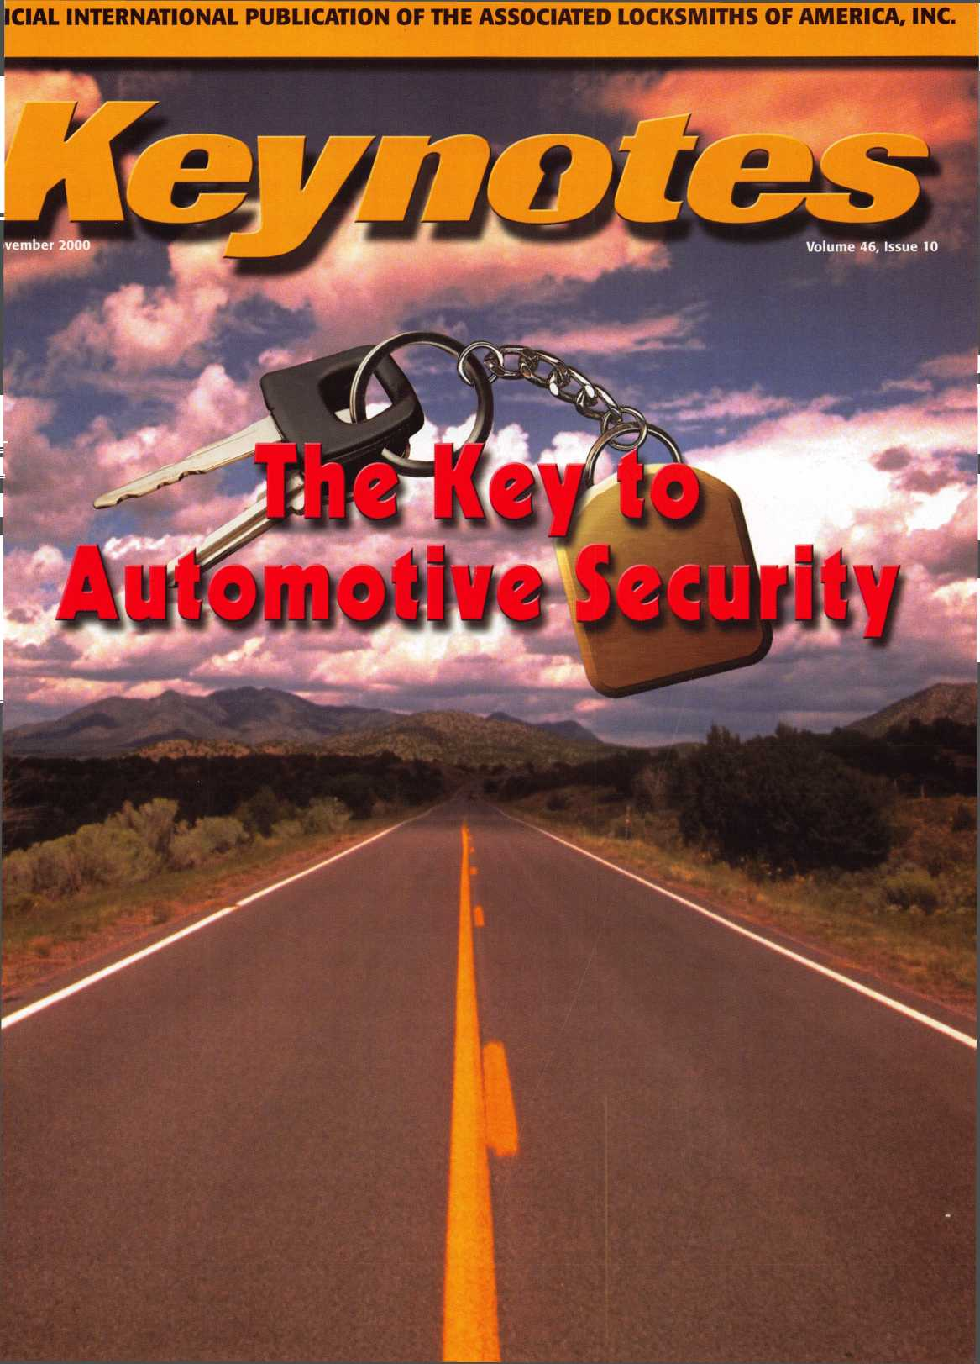

**Jump ahead of the competition  
at warp speed and see your profits soar.**

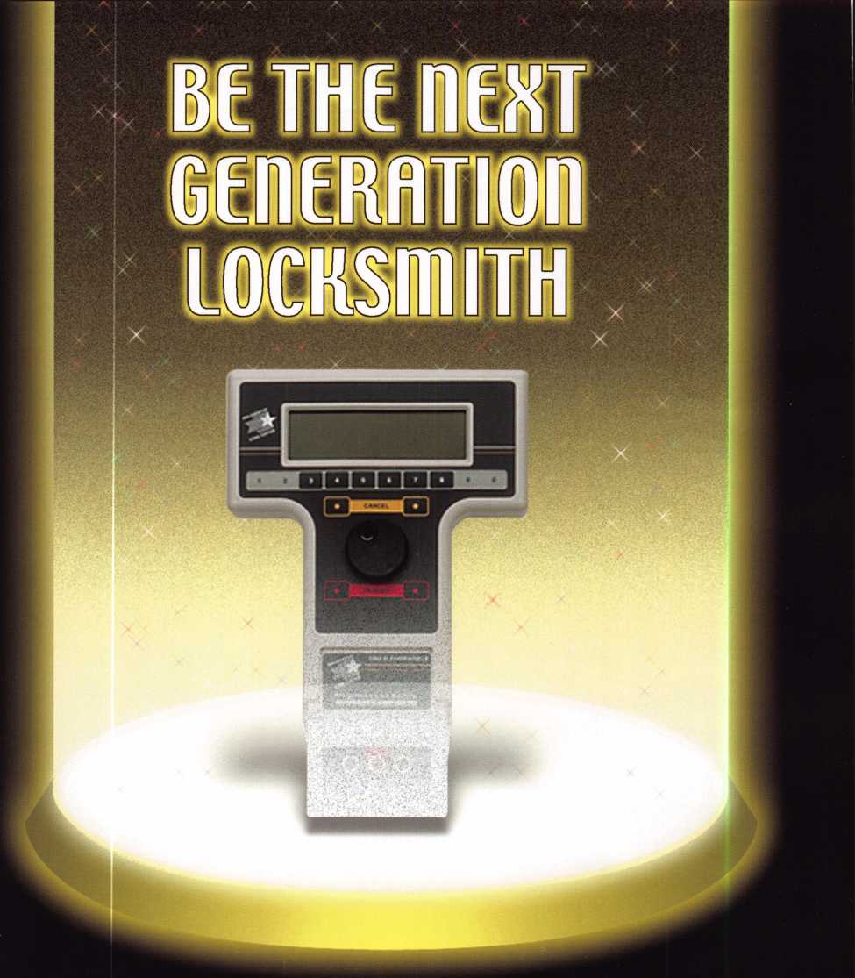

**Hickok’s New Generation STAR transports you with its advanced programming  
for keys to Ford-Lincoln-Mercury vehicles with passive antitheft systems.**

**Program vehicle keys through MY2000 with Hickok’s NGS Model 800-8LA—$1995**

**HICKOK**

**INCORPORATED**

phone 800/342-5080  
[www.hickok-inc.com](http://www.hickok-inc.com)



*Visit our Website on www. stamcctv. com*

THE COMPLETE

CCTV PROGRAM ON CD-ROM  
FOR STAFF TRAINING AND

PRODUCTIVITY ENHANCEMENT

STAM Insight has been developed to enhance CCTV skills and productivity with many different uses.

Productivity

t# System Drawing I# Estimation ll CCTV Training H CCTV Reference **00** Sales/Demo **00** System Design **00** Staff Evaluation

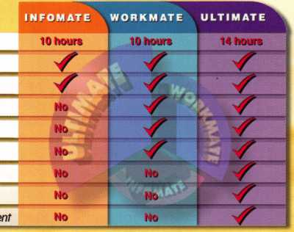

*CCTV Content CCTV Calculators* Demonstration Tool

*Estimation*

Drawing

Internet Enabled

in Over 50 Countries

Distributed by:

3003 Live Oak Street  
Dallas,Texas 75204



COPYRIGHT © 1996 Security Training and Marketing Pty Ltd. All rights reserved ACN 057 006 541

□ Yes, please send me a FREE PREVIEW CD ROM $9.95 S/H

Name:

Job Title:

Organization:

Address:

Country Tel: (

.Zip/Postcode, .e-mail

Fax: ( )

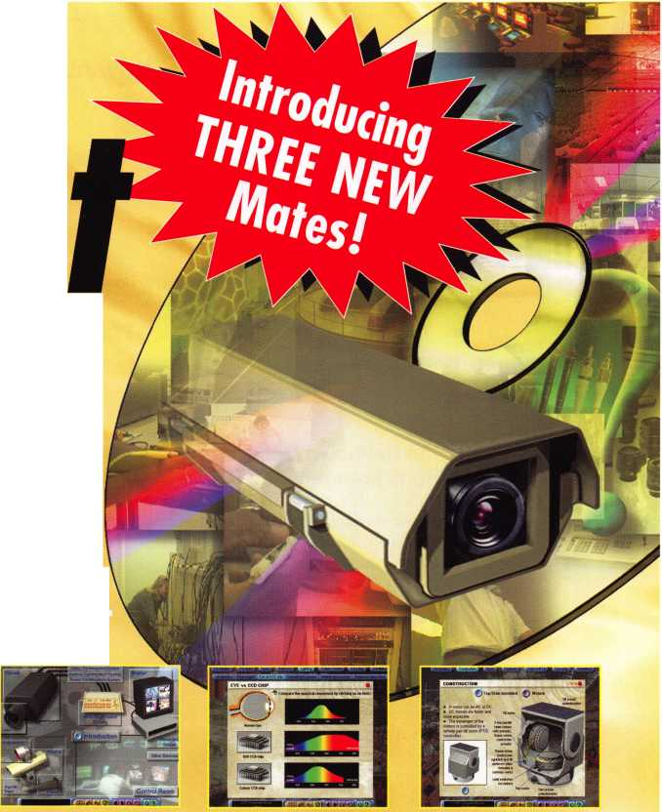

**Contents**

Features

**Nnvfimhftr**

- 00 |-J

**Volume 46, Issue 10**

**President’s Journey**

13

**AutoSmart Advisor**

Familiar with AutoSmart the reference book?  
Now read about AutoSmart Advisor, more than  
a book on”CD,” this is an “interactive” version

with a few extras.

By Sal Dulcamara, CML

**The Unknown Dangers of**

**Trunk Entrapment**

Unbelievably we are still experiencing fatalities  
due to the lack of an interior trunk release. A  
solution is on the horizon.

By Frank Markisello, CRL

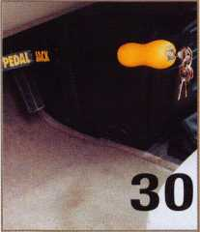

18

**Consider the Classics!**

Automotive locksmithing on the Classics can provide unexpected benefits — nostalgia and profit.

By Don Dennis

**Automotive Security 2001**

‘You can’t hot-wire this one!’

i

Art direction/design Phoenix Design 972.479.9026 ConQuest Graphixs 817.285.0003

By John C. Whatley

Reading a Lock with the SKT Reader This tool, first introduced at the 1999 ALOA Convention has been revised to accommodate the North American locksmith market.

By Tom Seroogy

28

**The National Locksmith Guide to Motorcycles on CD**

Those who would rather search and find than flip pages will be interested in the CD version of the book.

By Sal Dulcamara, CML

30

**The Pedal Jack**

This new auto security device is designed to overcome the many weaknesses of the various types of steering wheel locking devices.

By Sal Dulcamara, CML

Keynotes

November 2000

**Departments**

6

Core

8

10

12

Upcoming Events

Security Marketplace

Applicants for Membership

34

Legislative Update

44

Back Page

36

Classifieds

38

Associate Members

43

Ad Index

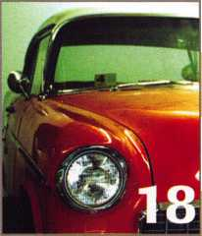

(staff^

Technical Editor Managing Editor

Editorial Advisor

Advertising Sales

Contributing Editors

Contributing Authors

Executive Director

Operations/Membership Manager Membership Coordinator

David Lowell, CML, CMST [david@aloa.org](mailto:david@aloa.org)

Patanya Johnson [editor@aloa.org](mailto:editor@aloa.org)

John D. Cannon, CML j [dcannon@worldnet.att](mailto:dcannon@worldnet.att). net

Marvin Diamond Native American Journal Co. (770) 993-3544 thediamonds @ mindspri ng .com

Paul Chandler, CRL Claire Cohen, CML Sal Dulcamaro, CML

Jerome V. Andrews, CML Brian Costley, CML, CMST Bob De Weese, CPL Ray D’Adamo, CML Michael A. Ferrill James Glazier, CML Daniel Graffeo, CRL, CMST Wayne Gurnee, CRL A.J. Hoffman, CML Ken Holmlund, CRL Ray Lusk, CML Mark Ohno Randy Simpson, CML Robert Stafford, CPL Dave Thielen, CML

Charles W. Gibson, Jr., CAE [charlie@aloa.org](mailto:charlie@aloa.org)

Mary May [mary@aloa.org](mailto:mary@aloa.org)

Shelly Jett

Executive

Additional contact information for the ALOA Board and most Keynotes authors is available through “Locksmith Search”' on the ALOA website- [www.aloa.org](http://www.aloa.org) or by contacting the ALOA office at 3003 Live Oak Street; Dallas, TX 75204; (800)532-2562;

FAX (214)827-1810; e-mail [aloa@aloa.org](mailto:aloa@aloa.org).

**3oard**



President

John J. Greenan, CML, CPS (773) 486-2030

Secretary

John D. Cannon, CML (703) 960-6413

Directors, Northeast

John C. Magee, III (856) 845-3434 Peter Sarailian, CRL (201) 947-6291 William L. Young, CML (610) 647-5042

Directors, Southeast

Thomas W. Tate (850) 476-4211 Donald E. Rule, CML (601) 324-2658

Directors, North Central

Mark E. Blum, CML, CPS (517) 482-5809 Tom Ripp, CRL (608) 262-3831

Director, South Central

Randy L. Simpson, CML (713) 780-7026

Directors, Southwest

Gordon R. Racine, CML (719) 384-4707 John A. Ilk, CRL (602) 420-2174

|  |  |  |
| --- | --- | --- |
| Mail Room Coordinator | Emmett McCrohan |  |
| Comptroller | Kathy J. Romo |  |
| Accounting Coordinator | Kathy Stokes |  |
| Government Affairs Manager/ | Tim McMullen |  |
| Chapters & Regional Associations Liaison | [tim@aloa.org](mailto:tim@aloa.org) |  |
| PRP/Education Manager | David Lowell, CML, CMST [david@aloa.org](mailto:david@aloa.org) |  |
| PRP/Education Coordinator | Ashley Manson |  |
| Meeting Coordinator | Thom Terry |  |
| Information Systems Manager | Randy McChristian | Wiss^ |
| Network Specialist | Greg Jackson |
| Receptionist | Alin Valdez |  |

Mission Statement: The Associated Locksmiths of America, Inc. is dedicated to enhancing the professionalism, education and ethics among locksmiths and those in related sectors of the physical security industry. With approximately 10,000 members in the United States, Canada and the freeworld, ALOA is poised to help members obtain the knowledge, the strength, and the confidence to perform their role in the physical security field with pride and dignity. But it is only through active involvement and participation that ALOA can fully achieve its potential-and can help members to achieve theirs.

Policies: Keynoted is the official publication of the Associated Locksmiths of America, Inc. (ALOA). Keynotes® acts as a moderator without approving, disapproving, or guaranteeing the validity or accuracy of any data, claim, or opinion appearing under a byline or obtained or quoted from an acknowledged source. The opinions expressed by the authors do not necessarily reflect the official views of ALOA. Also, appearance of advertisements and new products or service information does not constitute an endorsement of products or services featured by the Association. The Association does not accept responsibility for the inaccuracy of any data, claim, or opinion appearing in this publication, due to typographical errors on the part of the authors, Association staff or its agents. Editor’s Note: This publication is designed to provide accurate and authoritative information in regard to the subject matter covered. It is provided and disseminated with the understanding that the publisher is not engaged in rendering legal or other professional services. If legal advice and other expert assistance is required, the services of a competent professional should be sought.

Authors’ Payment: Payment for eligible submissions to Keynotes will be based on the following criteria: topic, time spent and past contributions. Authors who regularly submit to Keynotes are generally paid a higher rate. The latter is especially true of authors who write to fit specific editorial needs and submit said copy by Keynotes deadlines. As a general guideline: Average payment for a 750 word, business or ‘light’ technical article would be $200. Payment for a 1500 word article involving significantly higher time and research efforts would be $400.

Payment will not be offered for articles submitted by ALOA employees or members of the ALOA Board of Directors (unless material is of a technical nature), nor for articles submitted by a company that promote that company’s products or services. ALOA reserves the right not to pay for articles submitted by an individuals) that promote a particular company’s products or services.

Disclaimer: The Associated Locksmiths of America, Inc., (ALOA), reserves the right to refuse any article for any reason. Additionally, ALOA reserves the right to edit, amend or modify any article submitted for publication in order to preserve technical accuracy, clarity, fairness or grammatical correctness. ALOA will make the best efforts to notify the author of any changes. The extent of ALOA’s liability for any article or information contained therein will be a notice of correction or retraction in the next possible issue.

Keynoted (ISSN 0277 0792) is published monthly except for the combined June/July issue by The Associated Locksmiths of America, Inc., 3003 Live Oak St., Dallas, TX 75204-6186. Telephone: (214) 827-1701; FAX (214) 827-1810; e-mail [aloa@aloa.org](mailto:aloa@aloa.org). Subscription nates for members-$15.00 per year. Second class postage paid at Dallas, Texas. POSTMASTER: Send address changes to: Keynotes, 3003 Live Oak St., Dallas, TX 75204-6186. © Copyright 1999, All rights reserved. No part of the contents may be reproduced or reprinted in any form without prior written permission of the publisher.

Director, Northwest

Scott L. Henke, CRL, CPS (907) 248-3785

Director, Associate Members

David F. Matthies (727) 541-5536

Trustees

Dallas Brooks

(334) 826-8990

David M. Lowell, CML, CMST

(800) 532-2562

Breck H. Camp, CML

(770) 455-6244

Edwin Toepfer, RL

(416) 225-5589

Past Presidents

1997-1999 Dallas C. Brooks 1995-1997 David Lowell, CML, CMST 1993-1995 Breck Camp, CML 1991-1993 Henry Printz, CML 1989-1991 Evelyn Wersonick, CML, CPS 1987-1989 Leonard Passarello, CPL 1985-1987 Joe Jackman, CML 1983-1985 Stanley Haney, CPL 1981-1983 Louis LaGreco, CPL 1979-1981 John Kerr, RL 1977-1979 Clifford Cox, CML 1974-1977 Charles Hetherington 1972-1974 Gene Laughridge 1970-1972 William Dutcher, RL 1968-1970 Constant Maffey, RL 1966-1968 Harold Edelstein, RL 1964-1966 William Meacham 1962-1964 Robert Rackliffe, CPL 1960-1962 Edwin Toepfer, RL 1956-1960 Ernest Johannesen

***Keynotes***



November 2000

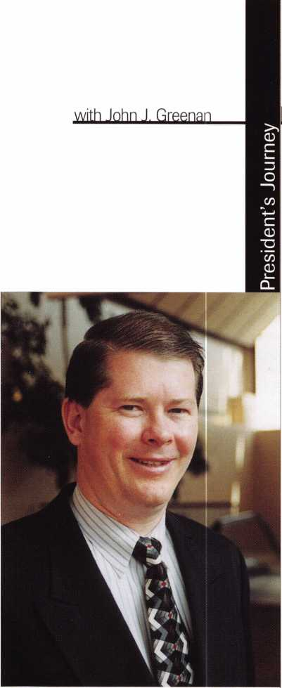

November 2000

What a year!

ALOA has had an exceptional year, thanks in part to the new direction the Board has given the association. From our legislative and educational efforts, to our best-ever convention, ALOA is positioning itself for the 21st century.

We recently held our Board of Directors meeting in conjunction with SERLAC in Jacksonville, Florida. One of the biggest things to come out of the meeting is that starting in January 2001, we will be using ALOA with the tag line, “An International Association of Security Professionals.” The Board determined that changing the name of the association was not in our best interest at this time, and that this was a viable and timely solution.

The association had one of its better years. Our profit was above the budgeted amount, and exceeded many expectations. This is due in large part to our governance policy, and our outstanding convention. By the first of October this year, we had over 7,700 ALOA members. Our convention had a total attendance, including exhibitors, of 4,662, making it the largest in ALOA’s history. Those that were there, I’m sure can attest to how successful it was. At this year’s convention we also held our first-ever live auction, which brought in $28,000 for the ALOA Scholarship Foundation. Booth reservations for next year are already at an all-time high, and Baltimore is shaping up to be another record-setting convention. Don’t miss out on being there July 15-22, 2001.

The Education Department worked hard this year to provide over 200 classes at convention and for various regional associations. It must have paid off, because this was one of our biggest years for new certification designations. Speaking of regional associations, we now have 14 Association Affiliates of ALOA. This will give us a stronger presence in nine states and Canada when we are in the legislative arena. If your association hasn’t signed up already, then call Tim McMullen at the ALOA headquarters today! This year, we had numerous successes on the political front as well, highlighted by ALOA and the locksmith associations in Tennessee working closely together to defeat a horrific “Do Not Duplicate” bill.

As we head into the future, we are looking forward to setting new records and providing more services to our members. I am looking forward to building upon the success of this year for the good of ALOA members and the industry!

John J. Greenan, CML, CPS

j Keynotes

Associated Locksmiths of America

Member Name Number of Sponships

Kwok-kei Leung 202

Toshihiro Asano 108

Henry W Raymond 93

Yuriko Yanai 68

Mary S Ohmit CPL 66

Charles C Robertson CML 65

Jack Hobin CPL 51

WilbamB Neff CML 43

Salvatore J Dulcamaro CML 40

Myeong-Rae Cho 38

Dana L Barnum CML 35

Barry K Leas CRL 35

Danny W Rudd CPL 31

Larry A Wamick CML 31

Jeanne G Lodge CML 31

C Allan Halverson 28

Anthony J Ramunno CML, CPS 26

James M Watt CML, CPS 26

Jeffrey S Nunberg CML, CST 26

J Thomas Hood CML 26

Jim Wilhams CRL 26

Lawrence F Smith Jr, CML 25

James H Glazier Sr, CML 25

Robert H Stafford CPL 25

William Lee 25

John C Elliott Jr, CML 24

Jerome L Cohen CML 23

Peter K Gauthier CPL, CPS 23

The Brightest

And The Best

|  |  |  |  |
| --- | --- | --- | --- |
| Robert F Carroll CPL | 23- | Jon B Griswold CML | 14 |
| Robert D DeWeese CML | 23 | James T Brickler CRL | 14 |
| Marian M Swann CRL | 22 | Man S Seo | 14 |
| Diana R Barnum CRL | 22 | Joseph C Fuller CPL, CMST | 13 |
| Elvis D Hammerschmidt CPL | 22 | Leonard J Passarello CPL | 13 |
| James J Cawby CML, CPS | 21 | Frank D Hartung CML | 13 |
| Eugene R Altobella Sr | 21 | Joseph W Whitaker CPL | 13 |
| John L Shandy CML | 19 | Robin A Horsley | 13 |
| Hans Mejlshede CML | 19 | Paul M Souber | 13 |
| John S Dorsey CML | 19 | Donald H Shiles RL | 13 |
| D Michael Lee Sr, CPL | 18 | Richard C Sievers | 13 |
| James E Fowler Sr, CML | 18 | JoeJ Lee CRL | 13 |
| David C Harris CML | 18 | Ernest W Wright | 12 |
| Philip A Rovenolt CPL | 18 | Rolando Bouza | 12 |
| Peter R Hall | 17 | Raymond C Lusk CML | 12 |
| Thomas G Vandersteen CML, CPS | 17 | John F Engel CRL | 12 |
| William P Grant CRL | 17 | Eric F Veal | 12 |
| Keizo Takahashi CRL | 17 | Basil W Shannon CPL | 11 |
| Evelyn V Wersonick CML, CPS | 16 | William J Wickward CML | 11 |
| Joseph P Ferrero CML | 16 | Calvin G Harris CML | 11 |
| Gary F Teams CPL | 16 | Herbert C Dusenberry CML, CPS | 11 |
| Robert W Duman Sr, CML | 16 | Timothy K Chow | 11 |
| Michael D Robinson CRL | 16 | Dale L Knowles CPL | 11 |
| Brian J Reetz | 16 | Thomas J Demont CML, AHC | 10 |
| Maurice Benson | 16 | Alvin N Minor | 10 |
| Walter W Lascar RL | 15 | Gene Eldridge CPL | 10 |
| William J McElheney CML | 15 | Ronald P Riggins CML | 10 |
| Russell P Fuller CRL | 15 | Lester S Brodsky | 10 |
| Michael B Groves | 15 | Larry L Votaw CML | 10 |
| Daniel L Landry Jr | 15 | Thomas R Smith CPL | 10 |
| Robert C Rodocker CRL | 14 | Richard T Johnson CPL | 10 |
| James E Gruber CRL | 14 | Dale V Crosby CPL | 10 |
| Michael E Jordan Jr, CML | 14 | James V Hawley CRL | 10 |

How can I join the President's Club?

You can earn membership in this prestigious dub by  
recruiting just 10 new members for ALOA.

*Any ALOA member may participate.

What do I get?

When you recruit 10 members, you receive a handsome  
blue blazer with a President's Club crest. For each  
additional five members you recruit, you receive a  
lapel pin with gold-filled numbers, indicating your  
recruiting successes.

You also get the satisfaction of knowing that you are  
helping your association, helping your industry grow,  
and you are helping fellow locksmiths achieve success.

How do I get started?

Contact the ALOA office for a supply of applications  
(800) 532-AL0A or FAX (214) 827-1810. One President's  
Club credit is awarded for each new applicant. Credit is  
awarded only after the membership application is  
approved. However, the credit will apply for the period  
in which the application is received. Failure to identify  
yourself as the sponsor on the application form at the  
time it is submitted to ALOA for processing will forfeit  
any credit.

*ALOA Board of Directors not eligible for membership in the President's Club.

November 2000

Keynotes ll

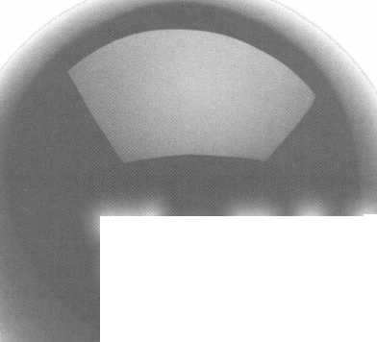

c n r r

* ASSA ABLOY has closed the acquisition of Yale Intruder Security

As of September 1, 2000 ASSA ABLOY and Yale Security Group have consolidated. The two groups have complementary strengths and there is little geographical overlap. With this acquisition there are considerable organic growth opportunities available through cross selling within the group.

ASSA ABLOY has a strong presence through its sales companies in Eastern Europe and South East Asia, while Yale Intruder Security division has a strong presence in Mainland China, South Africa and South America.

At the present time ASSA ABLOY is pursuing steps to acquire Tesa SA, a Spanish company within the Tesa Group. Tesa Entry Systems, Inc. manufactures electronic hotel locking systems in competition with ASSA ABLOY’s subsidiary, Vingcard.

* Ingersoll-Rand Selected One of the World’s 100 Best-Managed Companies

Ingersoll-Rand is on the list of Industry Week’s 100 Best-Managed Companies for the fourth year in a row. Ingersoll-Rand is a diversified industrial equipment and components manufacturer serving the global growth markets of Climate Control, Industrial Productivity, Infrastructure Development, Security and Safety.

Candidates for this award were pulled from the Industry Week 1000, a list of the world’s largest publicly held manufacturing companies based on revenues. Each company was selected after a lengthy evaluation that included the following steps: Analysis of the company’s financial performance; review of a questionnaire that each IW 1000 company was given an opportunity to complete; research into each company’s practices in areas such as philanthropy and safety; and voting by a panel of more than 90 business leaders, analysts and academicians.

* Briefs

The Greater Alarm Company, Inc., one of California’s largest electronic security and fire protection service providers has expanded its Northern California Operation in San Jose.

Adams Rite Manufacturing Company has a new

Website. Log on to [www.adamsrite.com](http://www.adamsrite.com) to see the expansion of products and services offered by Adams Rite.

* Regions

The election of new offers of CFLA will be held on November 15 at the monthly meeting. The meeting is scheduled for 7:30 pm at Marks St. Center.

The Grand Chapter of ALOA will hold its 15th Anniversary Banquet on November 18, 2000 in Phoenix,

AZ. For more information contact Louie at (602) 722-1532.

ALOA offers PRP/STPRP testing every second Friday of each month at the ALOA Headquarters, 3003 Live Oak St, Dallas, TX 75204. For information contact Ashley Manson at (214) 827-1701 Ext. 30.

* Obits

ALOA bids farewell to a  
familiar face at the ALOA  
Headquarters. Faustino  
“Tino” Leos founded Tino’s  
Landscaping in 1965 and  
was the caretaker of the lawn  
at the ALOA Office for the last  
20 years. He is survived by his  
beloved wife of 50 years, Maria  
Dolores, 5 sons, 3 daughters,

26 grandchildren and many  
other relatives and friends.

Tino will truly be missed.

* EXECS

Mark Miller has been  
appointed the new President of  
Lockmasters, Inc. Most recently  
he was president of the Tool and  
Equipment Division.

Secura Key is pleased to announce  
that Bill Newill has accepted  
the position of National Sales  
Manager. Bill will direct the  
sales efforts, while managing  
their Rep organizations and  
developing their new Certified  
Dealer Program as well.

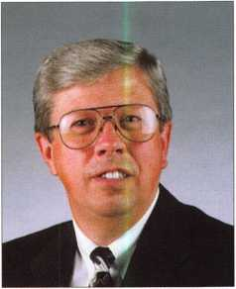

Bill Newill

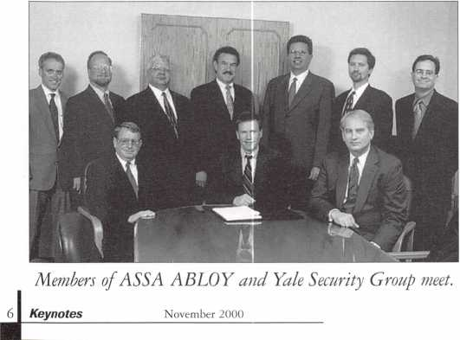

The Originals Stand Alone.

Only STRATTEC can supply the 2000 Taurus and Sable transponder keys, along with other original Ford, DaimlerChrysler, GM, and Mitsubishi models. Only STRATTEC is America's largest transponder key OE supplier. So only STRATTEC's keys hit the market the same time the new cars do. Alone among the competition, STRATTEC has the technological experience that comes with leadership. Nobody else offers the STRATTEC seminars that keep you up to date with the latest in security technology. Nobody else gives you that kind of support; the originals stand alone, so you don't have to.

599452 - Chrysler RFID Valet Key 89 Groove **690556**

**690222 -** Chrysler RFID Primary Key 84 Groove 690554

**690224 -** Chrysler RFID Valet Key 85 Groove 598335

**690226** - Chrysler RFID Key 90 Groove **599902**

**599450 - Dodge** RFID Key 90 Groove 599179

599455 - Dodge RFID Key 84 Groove 599114

690504 - Jeep RFID Master Key 84 Groove **598992**

**690223** - Neon RFID Key 84 Groove **599479**

**690552 -** General Motors 75 Groove RFID Key

■ General Motors Primary 88 Groove RFID Key

* General **Motors** Valet 75 Groove RFID Key
* Ford Primary Molded 82 Groove PATS Key
* Ford Primary Molded Encrypted 82 Groove PATS Key
* Mercury Sable Primary Molded Encrypted 82 Groove PATS Key
* Ford Taurus Primary Molded Encrypted 82 Groove PATS Key
* Mitsubishi Primary Molded 90 Groove RFID Key
* Mitsubishi Valet 89 Groove RFID Key



Upcoming

Events

Dept

\ , Indicates ALOA ACE Class r Indicates PRP Sitting

NOVEMBER

1-5

Yankee Security Convention Ace Classes (15 Classes)

ALOA PRP Sitting Sturbridge, MA (800) 209-8266 Contact: Robert Mahoney (860) 643-6922

4

Educational Update on Automotive Lock- smithing

Presented by Steve Young Maplewood, MI Minnesota Chapter of ALOA Contact: Leo Volkmann, CRL (320) 274-3247

4-6

ALOI/MLA Joint Convention Dublin, Ireland Tara Towers Hotel Hotel Reservations 353-1-2694666 353-1-2691027 fax

10

f/ ALOA PRP Sitting Dallas, TX

Contact: Ashley Manson (214)827-1701 (214) 827-1810 fax

11

f/ ALOA PRP Sitting Raleigh, NC

North Carolina Locksmith Association Contact: Granger Marley, CML (919) 859-6060

18

15 th Anniversary Banquet Grand Canyon Chapter of ALOA f/ ALOA PRP Sitting Phoenix, AZ Contact: Louie (602) 722-1532 Contact John Ilk (602)574-3277

19

ALOA PRP Sitting Honolulu, HI Clark Security Products Contact: Ron Cooling (619) 718-7301

DECEMBER

3

fk ALOA PRP Sitting Dalton, GA

Contact: Stephen Gebbia, CML (770)455-6242

8

f/ ALOA PRP Sitting Dallas, TX

Contact: Ashley Manson (214)827-1701 (214) 827-1810 fax

2001

FEBRUARY

3

Ace Classes

Electronic Safe Lock Class Alabama Locksmith Association Contact: Dallas Brooks (334)826-8990

6-11

2001 Annual Convention & Trade Show Austin, TX

Omni Austin Hotel Southpark The Texas Locksmiths Association Contact:

Registration:

Jim Hetchler (380) 606-1727 Exhibits:

Robert Hernandez (210) 433-5397 General info:

Judy Clifford (979) 297-2413

MARCH

23-25

ALOA Spring Board Meeting Dallas, TX

28-April 1

MLANJ 2001 Annual Convention \^T\ Ace Classes f/ PRP Sitting Somerset, NJ Convention Contact:

(973)267-8884 (973) 538-2248 fax [www.mlanj.org](http://www.mlanj.org) PRP Contact:

Dan McGlynn, CML (732) 634-4605

April

14

f/ ALOA PRP Sitting White Bear Lake, MI Minnesota Chapter of ALOA Contact: Alan Morgan (763) 566-2637

30-May 5

SAFETECH 2001 St. Louis, MO (214)827-7233

MAY

10-12

IDN 2001 Trade Show & Security Conference Ypsilanti, MI

Contact: Fred Strasberger or Bonnie Weston (800)521-0955

JULY

15-22

ALOA 2001 Security Expo Baltimore, MD (800) 532-2562

OCTOBER

15-21

Tri Regional Locksmith Conference Portland, OR

Pacific Locksmith Association Contact: Stan Hauer (503)325-7334 Email [hauer@pacifier.com](mailto:hauer@pacifier.com) Contact: Ken Mead (503)873-6932

2002

**JULY**

22-28

ALOA 2002 Security Expo Rosemont, IL (800) 532-256

MasterLink Security Products

ROGER ALEXANDER-TUTTLE understanding the needs of locksmiths...”

Mortise/Rim/Knob Cylinders • Storefront Door Hardware  
Cabinet Locks • Chain • Key Blanks • Padlocks • Pins ...and more

Local: (954) 730.9669 • Toll Free: (877) 347.9669  
Fax: (954) 486.0575

e-mail: [masterlink@mindspring.com](mailto:masterlink@mindspring.com)

3863 NW 19th Street, Lauderdale Lakes, FL 33311

Keynotes

November 2000



YOUR VIEW OF

SAFE TECHNOLOGY

A WHOLE NEW SHAPE

IN ST. LOUIS

**The Ultimate Trip...for Safe Technicians.**

Unlocking impenetrable monoliths is no mystery to you—you've been doing that your entire career. You've also witnessed your industry in a constant state of evolution.

To keep up with "what's out there" attend SAFETECH 2001 - April 30 - May 5, 2001 in St. Louis. You'll appreciate the location—in one of America's most modernized cities, and the opportunity to explore the modernization of your industry. For more information call 214.827.7233, or email [convention@anet-dfw.com](mailto:convention@anet-dfw.com).

SAFETECH 2001-Shaping the future.

SAFETECH

**2001**

**A SAFE ODYSSEY**

**ST. LOUIS, MO**



Security

Marketplace



I Dept

Medeco High Security Locks

Medeco introduces the SiteLine™ Expansion Board a product that simplifies and expedites wiring for SiteLine Single Door Controllers. The Expansion Board features clearly marked connections for inputs, outputs and auxiliary connections to reduce wiring time and errors on Single Door Controller installations. The Expansion Board installing the Single Door Controller consists of three steps:

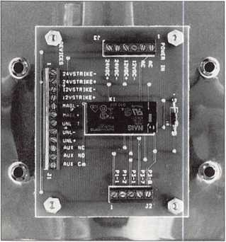

connecting the power source to the “Power In” terminal, connecting the selected Medeco door hardware to the “Devices” terminal and connecting a provided cable to the SiteLine Single Door Controller. Compatible power sources include the Medeco 12-volt AC Transformer and any Medeco 12-volt or 24-volt DC Power Module. Compatible electrical locks include any Medeco 12-volt or 24-volt DC electric strike and the Medeco MagLock and UnLatch.

The Expansion Board is also available as part of the SiteLine Modular Kit which includes: a 12-volt, four-amp hour battery; door kit; 12-volt and one-amp Power Module with wiring kit. Medeco

(800) 839-3157

InstaKey Lock Corporation

InstaKey has introduced instakey.com, a proprietary, real time, Internet-based software product for access control management. It is the first Web-based records management system that allows

10 | KeynotesNovember 2000

users to manage all forms of access control related data. InstaKey will enable senior security officers to actively manage the numerous access control devices within their security systems and take corrective action at anytime, from anywhere.

InstaKey (800)316-5397 www. instakey. com

Secura Key

Secura Key is proud to announce a new catalog on CD-ROM. Product data sheets, configuration guides and product training presentations are included on this disk. A free copy of this new CD may be requested by fax. Secura Key (800) 891-0020 (818) 882-0020 (818) 882-7052 fax mail @securakey. com www. securakey. com

Dorma Group North America

Dorma Architectural Hardware introduces the TS 68 door closer that provides reliable and versatile control of interior doors. The closure is adjustable to sizes 2,3 and 4 by selecting different templating locations. The TS 68 is quick and easy to install and does not require a mounting backplate. The non-handed closer has sweep and latch adjusting valves with properties to provide consistent closing speeds under a wide variety of temperatures. The TS 68 closer can be finished in aluminum,

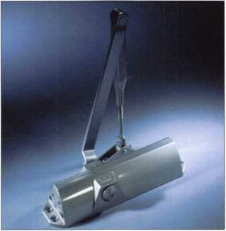

dark duranodic bronze and gold to complement a wide array of interior design needs.

Dorma

(800) 523-8483 www. dorma-usa. com

Von Duprin

Von Duprin has added the Recognition Systems, Inc. HandKey™ Ilv to its family of electrical security products. With this HandReader your hand is your key. In less than a second the HandKey™ Ilv verifies your identifica­tion by the size and shape of your hand. All information and data is inside the reader. The HandKey™ Ilv contains a complete door controller for entering and exiting and is compatible with most electrified locks, including electromagnetic locks, electric strikes and electrified exit devices. The HandReader is designed for single opening applications and is used as a stand-alone system in applications such as computer rooms, supply rooms, executive offices, pharmacies, fitness centers and Internet data centers.

Von Duprin

Ingersol-Rand Security & Safety (317) 613-8841

Illinois Lock Company

Illinois Lock Company is offering the world’s largest selection of switch locks for standard and OEM applications, including weather resistant, snap on and keyless remote control styles. Available features include, assorted levels of security, maintaining and momentary indexing, lengths starting at less than 1”, milliamps to 20 amps, singel and multi-pies, shorting and non-shorting contacts, static protection to 20KVDC, quick connect, soldering and PC terminals, custom wire harnessing, combination cam/switch locks.

Illinois hock Company 301 WHintz Road Wheeling, IL 60090 (847) 537-1800 (847) 537-1881 fax illock @aol. com [www.illinoislock.com](http://www.illinoislock.com)

Auto Smart

Advisor

by Sal Dulcamaro, CML

Most locksmiths who work on car locks already know about AutoSmart. It is the annually updated auto lock reference book by Michael Hyde. It covers everything from key blank information, to auto code series and applications and recommended key fitting procedures. The book breaks down everything into the various import and domestic brand automobiles and specific year applications. It’s the kind of reference book that helps you decide whether or not you have the

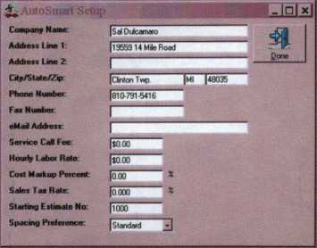

Figure 1

background (and/or equipment) to handle a particular automotive lock job. Sometimes it will keep you out of trouble, by warning you of things you might not have expected. You might either decide not to take a particular job and avoid some unnecessary grief, or you may take the appropriate precautions and do the job right and earn a decent profit on the way.

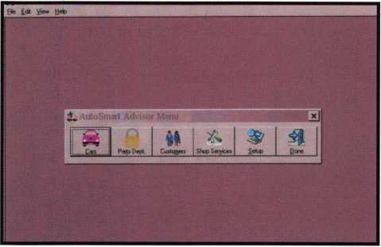

Figure 2

AutoSmart Advisor is a computer program. It is not just AutoSmart “the book” on CD, like “Guide to Motorcycles” reviewed elsewhere in this issue. It is sort of an interactive version of AutoSmart with a few extras. System requirements include: a PC with a 486 processor or greater; a minimum of 16 MB of RAM and 70 MB of available hard disk space; a mouse or other pointing device; a Windows supported printer for printing. AutoSmart Advisor will only work on Windows 95, 98 and NT. (Windows 95 requires SR-1). It will not work on a network, because the software security and the software license only includes two authorizations. More are available at additional cost.

After installing AutoSmart Advisor, you have two options. You can use the software on a trial basis for 21 days (after which the temporary authorization will expire), or buy the software/ authorizations up front which will not expire. When you make that choice, you will be directed to a setup screen, like that shown in figure 1. Toward the bottom, you will see lines for

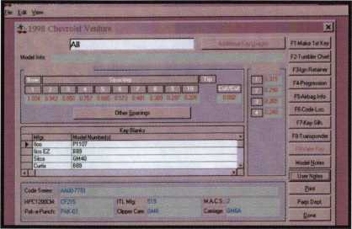

Figure 3

pricing information. This information will be used if you take advantage of the estimating/ billing/ invoicing features of the program. If you bill out a job, the program will figure labor time and product costs to figure your specific rate of mark-up.

After you complete the setup, you get the choices shown in figure 2. The part identified as “Cars” is mostly what you might expect from the printed version of AutoSmart. The main difference is that you select a specific vehicle (make, model and year) and the program will track down the specific information related to it,

November 2000Keynotes | 11

Applicants

For Membership

Dept

*The following applicants are scheduled for clearance as members of ALOA. The names are published for member review and comment prior to December 1,2000, respectively, to ensure applicants meet standards of ALOA’s Code of Ethics. Protests, if any, should be addressed to the Membership Department and must be signed. Active Membership applicants (A) have worked in the industry two or more years. Allied Membership (AL) applicants are not locksmiths, but work in a security-related field. Apprentice Membership (AP) applicants have worked in the industry less than two years.*

ALASKA

Anchorage

Willie Smalley Jr.

CALIFORNIA

Bakersfield

Floyd D. Bagley

San Francisco

Darren M. Inderlied

Escondido

Harvey A. Miller

Emeryville

David J. Fouke

San Francisco

Edward Cropley

Garden Grove

Christopher D. Shope

COLORADO

Colorado Springs

Clinton Moss

Riple

Terran L Sills

Castle Rock

John P. Burgdore

INDIANA

Nampa

David Augusta Gorvelli

MARYLAND

Laurel

Tood D. Cross Sr.

MINNESOTA Red Wing

Steven W. Polyard

MISSOURI

Springfield

Allan Phillips

NEW JERSEY

Pennsauken

Daniel R. O’Brien

West New York

Jose S. Veliz

NEVADA Las Vegas

Charles R. McHugh Jeff David Gause Mark W. Austin David M. Blankenburg

OHIO

Toledo

John H. South Robert J. Simpson

SOUTH CAROLINA

Charleston

WERE NOT JUST' KEYS...ANYMORE

Key Sales & Supply, one of the nation’s largest key blanks and tool suppliers, now stocks the most popular door hardware.

Prices subject to change.

IN STOCK:

Key Blanks Key Machines Locksmith Tools & Supplies Locks of All Types American & Foreign Automobile Locks Security Hardware (Wholesale Only)

AMI-AR3-KN1179A

41C-104C1

AM3-J41-1046

AR1-I35-1179

AR3-KN1179A

AR4-I35A-1179A

B1-98M-1098M

B2-H98M-H1098M

B5-98DB-1098DB

B10-H98LA-H1098LA

B1I-098LA-01098LA

B24-H98X-HI098X

B44-X98E-P1098E

B45498H-S1098H

B46-X98J-P1098J

B47-096K-S1098K

B48-P91A-P1098A

B49-S91B-S1098B

B50-P91C-P1098C

B51-S91D-S1098D

B52/B4-96X-1098X

BE2-A114A-A1114A

BN1-LS4P-K1122D

BO WL2-22B-R1003M

CG141G-1041G

CG241GA-1041GA

CG4/CG3-4IGR-1041GR

CG16-41R-1041T

CG17/KP1-41Y-1041Y

CG22-41RB-1041E

C01-20-1000

C03-21EB-1001EB

C07-21EN-1001EN

COIO-20G-1000G

CO26-20V- 1000V

C068-20VSS1000V

C087-2222-1001EH

C088/C066-A22Z2-A1001EH

C089-A22GM-A1001ABM

C091-A22A1-A1001AH

C097-K22-1001GH

C0106YHL1-R22B-1003M

DE6-54DR-D1054K

EAI-61-1014



Send in order or  
request order  
form.

v

EA27/EA5O-X61F-X1014F

EL10C1096CN

ER1-119-1119

FA1-FS4-1054WC

FR2-L54G-L1054G

H26-127ES-1127ES

H27-127DP-1127DP

H50-S27-SII67FD

H51-P27-1167FD

H54-PS23F3-11B4FD

H60-1190LN

H03-170-1170B

HR1-XB1FR-1014C

IN1-54F-1054F

IN37IN20-X54K-10S4K

IN8-LS4B-L1054B

IN18-X54F-X1054F

IN28S4FN-1054FN

IN29-1054UN

IN33-54MT- 1054MT

IN35-1054DL

K2-79HK-1079B

KW1-S4KS-1176

LI-35-1004

L4-35A-1004A

MI-92-1092

S6-049KM-N1007KMA S16-49KM-N1007KMB S22-043LA-01007LA S22-1/2-43LA-1007LA S32-48KMR-N1007RMB

1. 5IS-1010N
2. 51SA-L1010N SC1-145-1145 SC4-145AI145A SC6-307A-1307A SC7-145FS-1145FS SC8-145ES-1145E SC9-145E-A1145E SC10-145F-A1145F SC20-145L-A1145L SC22-307W- 1307W SE1-102-1022

M4-U92A- 1092V

M10-92N- 1092N

M11-92T-1092H

M27/M16-92NR-1092NR

NA12-174BN-1069LA

NA24-1069LC

NA2SM6-N174D-R1064E

NH1-N102-1177N

RA3-99B- SI970AM

RA4-99A-1970AM

RO1-62-1069

RO3-174J-1069N

RU1-55-1011

RU4S5P-1011P

RU1647PA-A1011P

RU45-57-1D-1011D1

RLH6-A57ID-AI011D1

SI-48-1009

1. 50-10IO
2. 060-1010U

SK1-R21EN-R1001EN

T3-111E-1141E

T7-111GE-1141GE

WEI-133-1123

WK2-175W-1175N

WR3-54WB-1054WB

WR4-54WA-A1054WB

WRS-54WC-N1054WB

WR6/FA2-F54A-A1054WC

XL7-XL16-11B0S

Y1-14-999

Y1E-E14-999N

Y2-14A-999A

Y3-14YM-C999

Y4-12GM-998

Y6-7X-997X

Y11-7HX-01122

Y12-07NX-01122A

Y13-R7NX-01122R

YI4-R07NX-OII22AR

Y52-7E-997E

Y54-07E-0997E

Y103-07B-01122B

Y149-S19-S1770U

Y152-P19A-P1770U

Y220-X14S-999B

STOCKING DISTRIBUTORS FOR:

Abus Lock Co.

Alarm Lock American Lock Co.

Arrow Lock

Auto Security Products BWD Automotive CCL Security Products Chicago Brinks Sales Detex

Don-Jo Mfg Co.

Dorma

EMTEK

ESP Lock Corp.

Fort Lock Corp.

Framon Mfg. Co., Inc.

HES

HPC, Inc.

Hudson Lock Co.

ILCO Unican Corp.

KABA

Keedex

Keystone Novelty Co.

Key Systems KSP

Kwikset Hardware Group

Master Lock Morse Toots Multi Lock, Inc. Olympus Lock S. Parker Hardware Pro-Lok Co. Progressive Hareware Sc Wage lock Co Simplex STRATTEC Supra

Trine Mfg Co.

Wilson Bohannan Co. Young Brothers



1-800-445-KEYS (5397)  
313-931-7720

Fax: 1-800-828-KEYS (5397)  
Local Fax: 313-931-7758  
9950 Freeland  
Detroit, Michigan 48227

Jeffrey J. Waite

TEXAS

Austin

Steve 1. Cothron Charlie N. Runnels

Burkbemett

Glen R. Hutchinson

Ft. Worth

William A. Stagg

Santa Anna

Boyd V. Copple

VIRGINIA

Arlington

Francis G. Michener

WISCONSIN

Plymouth

Jennifer Mason

Bermuda

Hamilton

David Wesley Hill

Canada

Estevan

Doug A. Bohnet

Keynotes

November 2000



instead of you searching through the pages of a book.

Figure 3 shows what came up when I selected “1998 Chevrolet Venture”. A column along the right side of the screen allows you to select various bits of specific information. If you choose “Make 1st Key”, you will get a list of recommended procedures for fitting keys with often two, three or more choices. The “Tumbler Chart” selection will typically identify the locations of tumblers in the various locks throughout the vehicle. You may have to click on an arrow to find details of specific locks. “Ignition Retainer” identifies how the ignition lock is held and removed. “Progression” will give a progression chart if one is typically used or available. “Airbag Info” tells where (if any) airbags are located. “Code Loc.” is supposed to tell you where codes may be located. “Key Silh.” is short for key silhouette, which shows a side view and key way profile. “Transponder” tells if transponder keys are used, and if so what specifications apply. “Valet Key” is only accessible if a valet key is used for the model vehicle. Model and User notes provide additional information and/or allow you to add and store your own relevant information. The print functions allow you to get a hard copy not unlike the information you might see printed in AutoSmart. “Parts Dept.” will get you into a list of lock parts connected to that vehicle and also usually prices.

Figure 4 shows what turned up when I selected “Parts Dept.” for 1998 Chevrolet Venture. This feature can be extremely handy when you are quoting prices over the phone. It can be a problem if you quote $ 13 for a new ignition lock, only to find that a rather unusual (but very expensive) lock is used on the particular vehicle that you are serving.

Overall Impressions

What makes AutoSmart Advisor more than just the AutoSmart book on CD is the extra features on

estimating and billing, plus the customer tracking information.

The “Cars” section goes back to I960. While most of the car infor­mation for the past 20 years or so seems to be rather solid, there seem to be a few minor glitches when you go back a lot earlier. Certain categories of information seem to be a bit canned and generic and not specific enough about a particular car. The code locations category seemed to give very little useful information especially in older GM

vehicles because it seemed to repeat the same “codes are usually found on the ignition”, but failed to account for the fact that early on, codes were on virtually every lock in the car. Even when codes came off the trunk and door locks, they remained on the glove box locks for quite a few years. For the years when the GM primary key worked the ignition and doors, selecting “Find 1st Key” would tell you to make a secondary key from the door lock, when it should have said

It's True

Marray has developed the first  
screwless door loop.

Aluminum ma­terial means true anodizing.

No off color powder coat­ing or painting

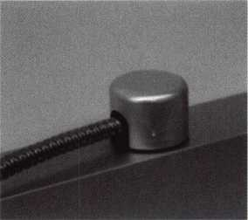

Standard 18” length. Can be ordered in cus­tom lengths

Plastic base stops shorts and pro­tects wires

Screwless base and cap means you drill two 1/2 inch diameter holes, pop the base into the hole, wire your system and snap on your covers. Simple as 1, 2, 3.

**Here’s the best part We are giving away a**

FREE SAMPLE TO THE FIRST 1 OO CALLERS WHO MEN­TION THIS ADD. A $14.40 WHOLESALE PRICE VALUE.

CALL TODAY, IT’S FREE!!

1-800-500-1449

**Marray *enterprises, inc.***

At **Marray,** we’re not just modifiers, we’re Master Hardware Modifiers™  
**1128 Walsh Ave., Santa Clara, CA 95050. wvyw.marray.com**

113

November 2000

Keynotes

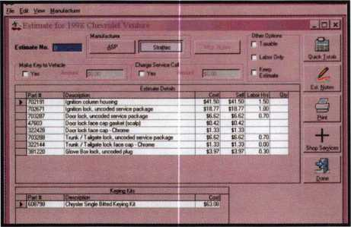

Figure 4

to use a glove box or trunk lock.

I suppose someone reading this might think I didn’t like the software. I actually thought it was rather good. This is just what you typically see on an ambitious project such as AutoSmart Advisor. I can tell you first hand, as a technical writer, that the time spent on research can sometimes seem endless. The fact is that you can’t expect the first edition of something of this kind to be without errors. Just as the first printed AutoSmart was good but not great, the same applies here. Each year (since the first edition) the printed

AutoSmart has improved in both variety and quality of content. It is now one of the best auto lock references you will find. I expect the same to happen with AutoSmart Advisor. The purchasers of the software will alert Mike to the various minor errors and glitches so that the second edition will have most of them corrected. I expect each new edition to improve the way AutoSmart did.

The fact is that there are not many of the older cars still on the road, so most owners of AutoSmart Advisor will probably have minimal contact with that part of the program. The other thing is that you can get the software as a full featured demo that expires after 21 days. You can use all features of the software, just with a deadline. I think that would give most locksmiths enough time to see how useful it is. You don’t pay up front. If you weren’t sufficiently impressed, you got to use it free for 21 days. If you loved it, you can get two authorizations (to run on up to two computers) for $395 without an expiration date. Authorizations to run on additional PC’s at your shop cost $50 each. For more information, contact: National Auto Lock Service, Inc., Phone: 800/954-5454. Find them online at: www. nvo. com/nat 1

This year, the ALOA Scholarship Foundation

awarded 25 full package scholarships to ALOA 2000 in  
Las Vegas, Nevada. Of the 25 awarded 21 recipients accepted  
and took advantage immediately by attending the classes offered

in Las Vegas. Ask any one of those recipients and they’ll tell you  
how the scholarship was beneficial in gaining knowledge for the  
improvement and development in the field.

The Scholarship Foundation worked hard at ALOA 2000 and will continue to work throughout the year to raise funds for future awards.

Don’t get left out next year. ALOA 2001 in Baltimore will provide more educational and career opportunities for locksmiths and others in the security industry. Take the time and complete the scholarship application at the right.

You can take advantage of one of our associations most valued resources and learn more about the trade. Who knows, you could be one of the next recipients. The ALOA Scholarship Foundation is waiting to hear from you.

14

Keynotes

November 20000



Scholarships are awarded to those individuals who demonstrate their financial need and their desire for more education in the locksmithing field. If you or someone you know fits the above criteria, please fill out the application on this page and send or fax to the ALOA Office at 3003 Live Oak St., Dallas, Texas 75204 by the due date on February 1, 2000. The fax number is [214] 827-1810. Don't forget to include your letter stating your reason for applying, your three letters of reference. No late or incomplete applications will be considered.

ALOA SCHOLARSHIP FOUNDATION, INC.

ALOA/SAVTA SCHOLARSHIP APPLICATION  
3003 Live Oak Street; Dallas TX 75204; (214) 827-1701

Please print or type

NAME PRP LEVEL ALOA/SAVTA #

HOME ADDRESS CITY STATE ZIP

HOME PHONE- DOB // EDUCATIONAL LEVEL [YEARS] DEGREE, IF ANY

PRESENT EMPLOYER WORK PHONE- FAX -

WORK ADDRESS CITY STATE ZIP  
POSITION □ FULL TIME □ PART TIME TAKE HOME PAY $

LENGTH OF TIME IN LOCKSMITHING OWNER/SUPERVISOR’S FULL NAME  
MEMBERSHIP IN TRADE ASSOCIATIONS [LIST BY NAME]

MARITAL STATUS SPOUSE’S OCCUPATION SPOUSE’S TAKE HOME PAY $

COMBINED HOUSEHOLD ADJUSTED GROSS INCOME $ NUMBER OF DEPENDENTS

CLASSES DESIRED DATE OF CLASSES //

ORGANIZATION SPONSORING CLASSES: □ ALOA □ SAVTA □ OTHER [PLEASE NAME]

LO C ATI 0 N

ALOA Scholarships are granted to selected individuals desirous of entering the locksmithing field or to selected individuals already in the locksmithing field who wish to improve their professional skills through education.

Applications for classes being taken locally must be received a minimum of 60 days prior to the date of the class, and will be reviewed as they are submitted. Scholarships for classes at the ALOA or SAVTA convention will be awarded each year at the ALOA Scholarship Foundation meeting preceding the convention and must be received by February 1 each year.

Please attach to this form a letter stating your reason for applying for a scholarship, what you plan to do with the knowledge you obtain and any other information you feel may be helpful to the scholarship board in making its decision. In addition, attach three let­ters of reference from individuals who have personal knowledge of your background and character. The letters should contain their names, addresses and phone numbers. It would be helpful if at least one of these references is an ALOA or SAVTA member.

All scholarship recipients will be required to provide a 3x5 inch photograph of themselves.

APPLICATION CHECK LIST

Only complete applications will be considered for scholarships. An application is considered incomplete unless ALL of the above requested information is received before the deadline: 60 days prior to the date of a class or February 1 for ALOA/SAVTA convention classes. Please send this application after checking off each of the below.

* I have filled in each blank on this form.
* I have written and enclosed a letter explaining my reason for applying.
* I have enclosed three letters of reference.
* I am submitting this in time to be received 60 days prior to the date of a class or by February 1 for ALOA/SAVTA convention classes.

CERTIFICATION OF APPLICANT:

I certify that the information contained herein, and all supplemental forms are complete and correct to the best of my knowledge. I further certify that if I am selected as a scholarship recipient I will use the knowledge gained for the improvement, development and advancement of the locksmithing profession.

Signature Date//

11/99

November 2000

Keynotes

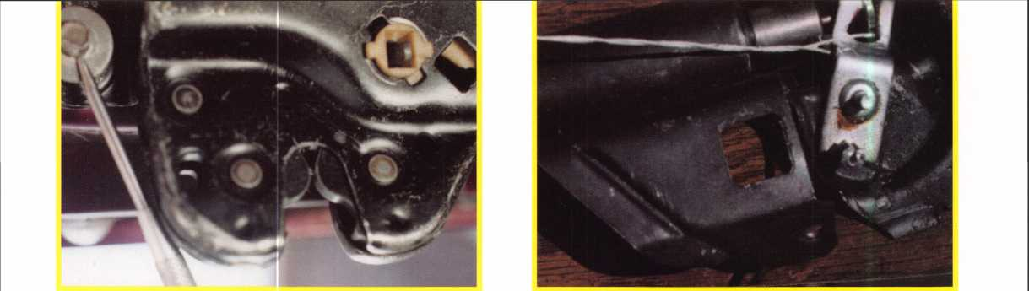

Photo 1. Remove the lock mechanism from the trunk lid. Photo 4. If the car has an electric opener, wrap wire around the

solenoid lever and hack out.

The Unknown Dangers

***What can be done? What is being  
done to prevent this tragedy?***

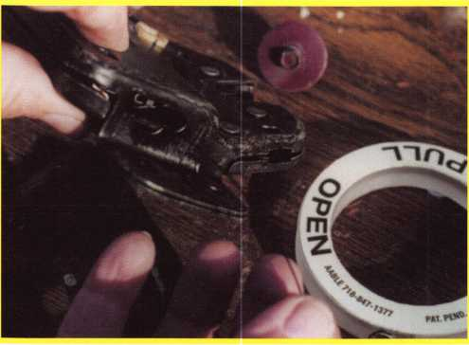

Photo 2. Run wire from the ring through any opening on the side of the lock mechanism. This will enable you to wrap the wire around the release lever and hack out where you came in.

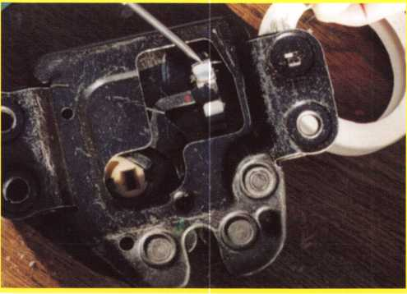

Photo 3. Wrap wire around the release lever and hack through the opening you entered.



Keynotes

November 2000

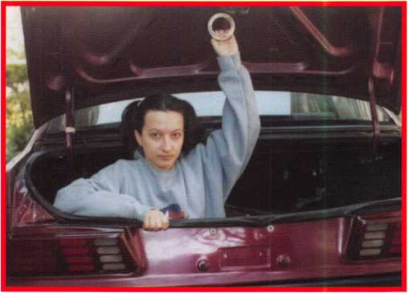

For many years it was against the law to put a refrigerator on the curb for garbage pick-up with the door still on the hinge. Why? Because a child could get trapped inside the refrigerator with no way to get out. This logic should have been used with car trunks. Naturally you can’t take the car trunk lid off, so there should be an emergency trunk release inside the trunks.

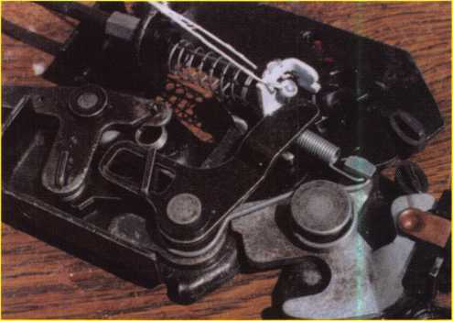

Photo 3. If the car has an inside front compartment cable hooked to  
the mechanism, wrap wire around the lever where the cable is  
connected as shown.

Photo 6. If the car is a GM or similar, wrap wire around the release as shown.

Photo 8. Reinstall the lock mechanism on trunk lid. Be sure tail from lock cylinder goes in slot on rear mechanism.

**of** Trunk Entrapment

***by Frank Markisello, CRL***

In the last several years there has been a growing rate of fatalities involving trunk entrapments, some involving small children locking themselves inside, as well as victims of carjackings being locked inside by their abductors. Due to this increase The National Highway Traffic Safety Administration requested that an expert panel be formed to address this issue and make recommendations on how to prevent trunk entrapments. Next month the panel will reconvene and implement the recommendations they have set forth.

By 2001 it should be mandated that all new cars have an emergency trunk release located inside the trunk of cars. What about the old cars? Well, I have already come up with a solution for older model cars. I have designed The Quick-Out Emergency Trunk Release to eliminate this problem. This device is child oriented and can be installed on virtually any trunk lock. It has a large ring that glows in the dark so it can easily be seen inside the trunk in the dark. The Quick-Out needs very little pressure to release the trunk hood.

Why design the Quick-Out? I felt that I as well as other locksmiths should share the responsibility in addressing the problem of trunk entrapment and finding a solution. We install alarms, locks, window bars and cameras for people to

feel safe and secure. This is one area we forgot about, the safety of our children and ourselves.

Quick-out can be installed in 15 minutes, depending on the type of vehicle. The basic installation is the same.

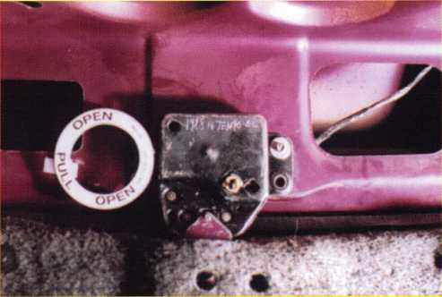

Photo 9. Take a square piece of Velcro from the package and install it on the trunk lid in line with and opposite the Velcro circle. (This is already attached on rear of ring.) This will hold ring in place. If someone has to get out of the trunk, just a slight pull on the ring will open the trunk.

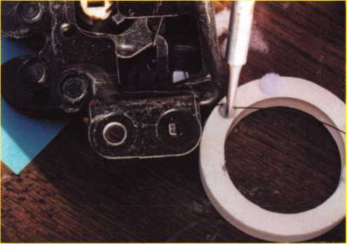

Photo 10. Glow in the dark ring can be seen easily .

Photo 7. Pull excess wire through until the ring comes in contact with the mechanism, then wrap wire around the side screw on ring. Tighten the screw and cut the excess wire.

November 2000

Keynotes



By Don Dennis

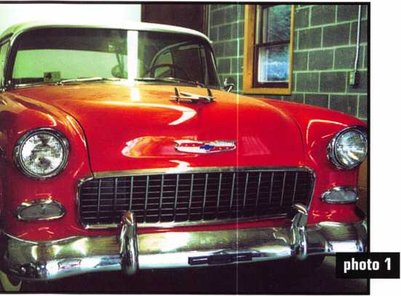

The 1955 Chevrolet Bel Air.

Lock cylinder is located below the door handle.

When I first talked about doing this article about classic automobiles, I began looking at what was available locally that would work to my advantage. It turned out to be a 1955 Chevrolet Bel Air. I would have probably chosen a Chevrolet product anyway if for no other reason than they were the first manufacturer to cause me problems when I was a young fellow starting out in the business back in 1970. First, I want to tell you a little bit of useful information and then something that I seemed to have fallen into. Nostalgia, of all things, hit me like a lead brick when I saw the ‘55 Bel Air. Most importantly, I want to explore what the classics and vintage automobiles might mean to today’s locksmith world.

1955 Bel Air Chevrolet

We are accustomed to having automobiles change every year as the new model year arrives. From 1955 through 1957 Chevrolet stayed, for the most part, consistent in it’s parts in terms of locks and how they worked. An example would be in the glove compartment lock. From 1955 through 1957 there is a screw on the backside of the cylinder housing that holds the compartment lock in place. This is also the case for other model years after 1957. However, in 1953 and before the glove compartment lock was held in place by a screwing face cap or bezel nut approach. It is most important that we not try and memorize how to work on a particular year or model of vehicle. It is important instead, to remember how things work within the framework of a particular manufacturer. Manufacturers have a tendency to regress and reuse ideas from the past. If you can do this then you will never find yourself stumped wondering where to turn for help.

,i

Keynotes

November 2000

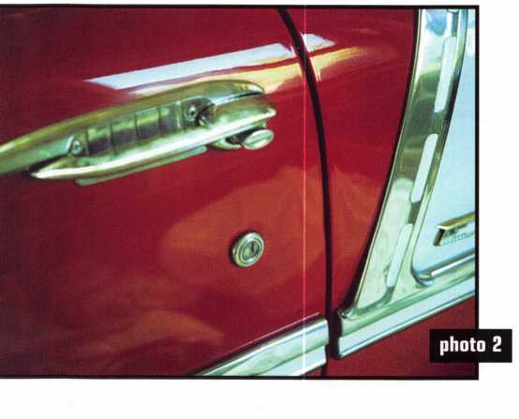

While I am talking about the glove box lock, I should mention that the lock cylinder has four tumblers and a retaining tumbler in its first chamber. We would pick the glove box to the locked position with the glove box opened and then insert a wire that would allow us to depress the retaining tumbler and then each successive tumbler until the cylinder plug was removed from the cylinder housing. The plug usually had a code stamped into it and this would give us our key. The glove box lock and the trunk lock are keyed alike. If the code was not there, which happened in later years, we would cut the key to the four tumblers in the glove box and then run a progression chart to find the missing cuts that are closest to the bow of the key.

The next key to make is a key that will fit the doors and ignition. If the locks that are in the car are original there will be a code stamped into the cylinder housing on the door locks. With the car door opened, roll down the window. This will leave a large gap at the top of the door, which will allow you to easily see, without the use of a wedge, the door lock cylinder.

A tool that is homemade, at this point, was very useful.

Taking a simple wire coat hanger, unfold it into a straight wire. Then fold it in half. This will allow a stronger handle. Lay an old toothbrush at the open ends of the hanger wire and using electrical tape, tape it all together. This extended handled toothbrush is then used to brush the side of the lock cylinder cleaning it for the viewing of the code.

HPC sold a tool that was a small flashlight with a plastic tube that would transmit the light to a small mirror at the far end. This would give us a means of seeing the code without dismantling the door panel and removing the lock cylinder. Remember that viewing the code by a mirror will give you an image that is backwards. Depending on which door you choose, the code may also be upside down! I have not seen this tool for some time now and you may find that you will need to be enterprising and make your own. An automotive inspection tool with a small mirror might be a good start. Remember that the code will be all numbers without letters being involved. It was not until 1970 that the codes disappeared from the door locks.

If things did not go according to plan then we have to take a more direct approach. If the glove box key did not fit the trunk, we would remove the back seat and remove the bolts of the lock body. This would open the trunk lid and would allow us to remove, disassemble, rekey, and reinstall the lock cylinder. If the door lock did not give us a key for the ignition, we would remove the ignition lock bezel cap as far as possible and drill a small hole to reach the plug’s sidebar (use to be known by the old-timers as a slider rather than a sidebar). Place pressure on the sidebar and pick the plug, rotating to the accessory position. Pushing a small wire into the detent hole in the face of the ignition cylinder, we would depress a

Trunk cylinder is between the license plate holder  
and Chevrolet emblem and uses a straight tailpiece  
to connect it with the trunk lock.

Not everything is perfect! The off position  
on the escutcheon is not quite lined up with the  
keyway but the dash mounting was difficult to work  
with considering the very large steering wheel.

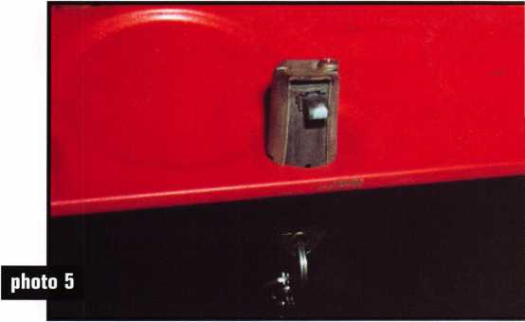

This glove box is held in place by the screw  
on the back of the cylinder. The metal housing that  
surrounds the lock is loose. The screw through the  
housing into the lock holds the entire assembly in place.

November 2000 Keynotes

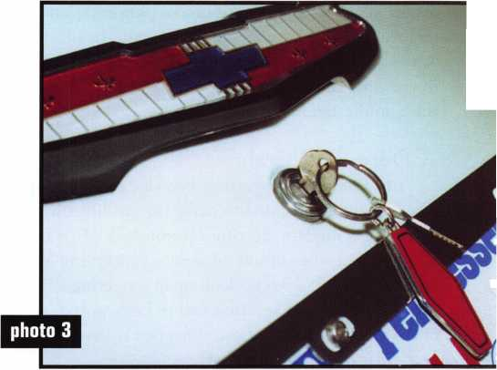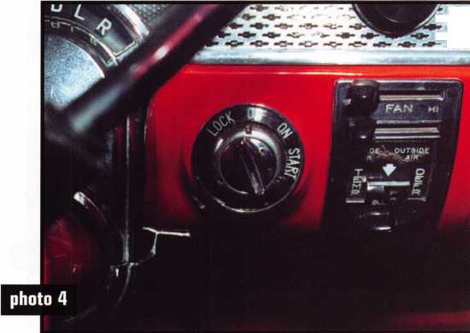

detent allowing us to continue the plug rotation making removal possible. Either the code would be on the plug or we would interpret the cuts by picking and holding in the sidebar viewing the tumblers beside the tumbler retainer cap.

A Dose of Nostalgia

I had hardly four years of knowledge under my belt when Chevrolet decided to make things difficult by inventing a modern steering column lock. It is hard to imagine with the current situations concerning VATS and airbags, but I would look upon a steering column lock job, where the ignition had to be removed, as one of the worst things that could happen to me on that particular day! Imagine that!

When I look at the differences in locksmithing in the early 1970’s and in the current requirements, it is amusing as well as a realization of how far our profession has come. For those older than I, it could be truly stated as seeing history from the horse and buggy to the space program. Our arsenal of auto opening tools consisted of the Slim Jim, a pouch of standard picking tools, and if you were really modern and up to snuff, a tool with “alligator” jaws that would pop open to lift door lock buttons! Now we use a suitcase of tools and with each new model year, we question our possible success.

I can also remember when Chevrolet and the rest of GM went to the Steering column lock starting in 1974. Before the steering column locking compression tool came to the locksmith, we were either making our own tool or we were taking up yoga to contort to a position that would allow us to do the ignition removal alone. I remember sitting on the back of the driver’s seat with my back pressing into the headliner and using my toes to compress the locking ring for removal of the spring clip. The first time I did that trick alone, I relaxed after popping the spring clip and my knees shot upward sending me into the back seat! I felt like a frog! Needless to say, I made a tool as soon as the Locksmith Ledger Magazine gave out a trade trick tip that year.

We have certainly come a long way.

Profit In the Classics?

Besides the large dose of nostalgia that this article has given me, the current potential for profit that is in the field of automotive locksmithing is enormous. With everything that one needs to know about the past and the current product lines and all of the idiosyncrasies that are inherent to so many different models, this endeavor of automotive locksmithing is quickly becoming a specialty within the profession. As a specialty develops within a profession a deeper look is generally given with research and product and tool development as the profession is streamlined and consolidated. This happens yearly by several developers of tools and supplies for the current models that are coming onto the market. These tools and supplies stay on the market for a portion of time until the demand is not great enough to rationally continue the production. Then they are dropped or picked up as a specialty by a small niche manufacturing company that will for a time carry on the tradition. I mention all of this not only because of the tools that have disappeared but also for the new tools that may reach our market. This is the reason that one of the photographs in this article has a recently produced new tool.

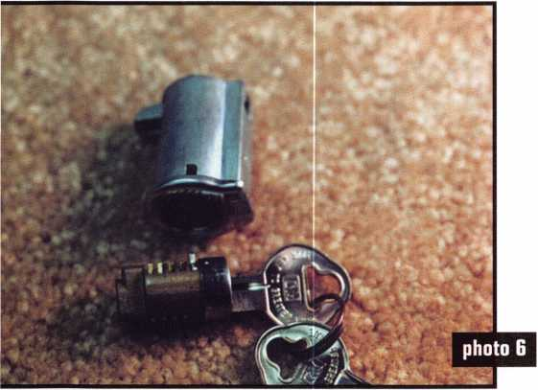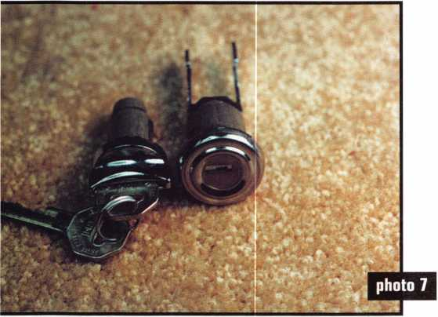

Here the glove box lock is disassembled. The one tumbler that is sticking out of the plug is the retaining tumbler that holds the plug into the cylinder housing.

The door and ignition cylinders are keyed alike. The  
door cylinder face cap has a raised circle that surrounds the  
'ey way and the forked pawl is fixed. The end of 1935 saw the  
introduction of a flat pawl arrangement on door cylinders.

Keynotes

November 2000

The Gator™ tool is very important to anyone that intends to do a lot of classic automotive work. As you can see in the photographs of the 1955 Bel Air, the caps have a ridge that circles the keyhole. It will be increasingly more difficult to find these caps. Anyone capable of mastering the Gator™ will be reusing face caps and handling successful classic jobs that would otherwise be lost.

There is a desire found in a portion of our population that loves and cares about old cars. This is a development that is continually growing. There are now all sorts of car clubs. I would go so far as to say that there is some sort of club or organization that is dedicated to the automobile in just about every part of the United States and for that matter the world. There is an organization for just about every manufacturer in the world and many of the clubs focus on just one model of a particular manufacturer. Examples would be the Ford Mustang, or the Ford Falcon, or the Chevy Corvair, or Corvette.

Why there are even the Super Chevy Shows that are taking place all across the United States. The classics and vintage automobiles are everywhere. Hardly a weekend goes by that I do not see a line of these auto­mobiles traveling along the nations interstate system!

I am building up to a statement that there is money for the locksmith in all of this. Whether you are a locksmith that deals only with the automobile or not, here is a segment of business that can be groomed for gaining a great reputation as well as more business dollars. When you become known for your ability in solving the problems and the rekeying of the hard-to-find locksets for the collectable automobiles, the collectors will come far and wide to gain your expertise. They will also pay the price you ask for your expertise. The best way that I have found in becoming part of this community is either as a hobby of your own or approaching it through a friend’s hobby. This will show the community of collectors that you have a love for their own passion and this love will translate to the care that you will give to their prized possession. This plus going to the shows and events, like the Super Chevy shows, and handing out your business cards will place you right into the middle of a very lucrative element of automotive locksmithing.

Sources

While working on this article, I decided to try and find a new set of locks for the 1955 Bel Air. I needed a set of locks that was ready to be installed.

They were properly keyed and their appearance would be acceptable by the classic community. In looking at all of the literature on the bookstands, the most helpful

publication was produced by the monthly editions of Hemming Motor News. Through this publication I found a supplier/manufacturer called Danchuk. This company carries parts for Chevrolet automobiles from 1955 to 1957. They not only had all of the cylinders found in this article but they manufacture their own ignition switch for the ignition plug. There are also existing companies that support other classic and vintage automobile manufacturers. You also have other alternatives. You have everything from friends leading you to totally ruined cars in barns to junk yards where you can find complete sets of old locks. These contacts, with a little effort and working with the clubs and even advertising in the part sales publications, will lead you to higher business exposure and more profits. All that is really needed besides a little education is the right locksmith with the proper motivation and a love for automotive history.

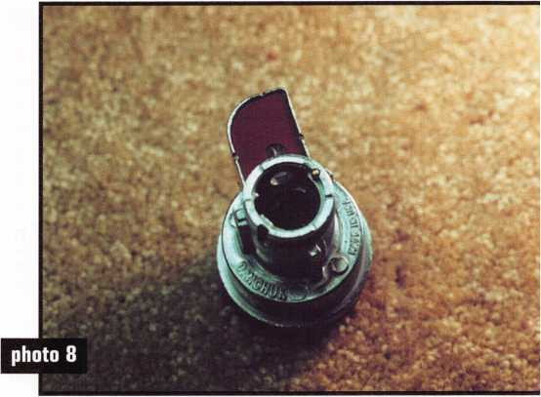

This ignition switch is actually made by Danchuk as a replacement for the original.

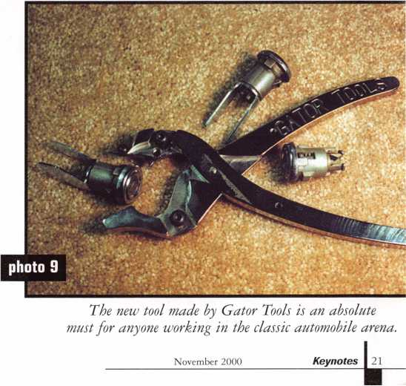

Super bearing construction.

Superior rigidity and accuracy.

Shipped with carbide cutter.

2 year parts and labor warranty.

Increased cut rates:

Laser mode 8 seconds.

Standard mode 12 seconds,

Bi Axial 6 pin 17 seconds,

New Medeco Autoswing head option.

CD LO il) IS 8 mCUBfflB LHDLDQQ

Li mass

WEAR EYE PROTECTION

* Up to 800 built-in manufacturer depths and spaces.
* Works with most popular Master key systems.
* Serial port to communicate with user systems.
* Repeatable accuracy of l/1000th inch.
* Dependable heavy duty construction.
* 1 year parts and labor warranty.
* Cuts Medeco™ High Security keys with angled cuts.

The ITL 9000 was built by locksmiths — we know what you wanted so we built it. When a new lock comes out you add the space and depths immediately. No Mechanical adjustments. All sealed and prelubricated bearings.

ITL-9000

CDGOCDOD

EHBIDOD

KDSHSM

□GD61DD

Uses either 12 or 120 volts.

All manufacturer depths and spaces built in, Heavy duty construction.

12 month warranty.

Built in Master key System.

**TOOLS LIMITED**

— **Now Distributed Throughout USA, Canada & Australia** —

2639B Progressive Way • Abbotsford, BC Canada V2T6H8  
USA: 562-699-0060 • Canada: 604-852-8904 • Canada Fax: 604-852-8938 • Toll Free: 1-888-264-6627

Keynotes

November 2000

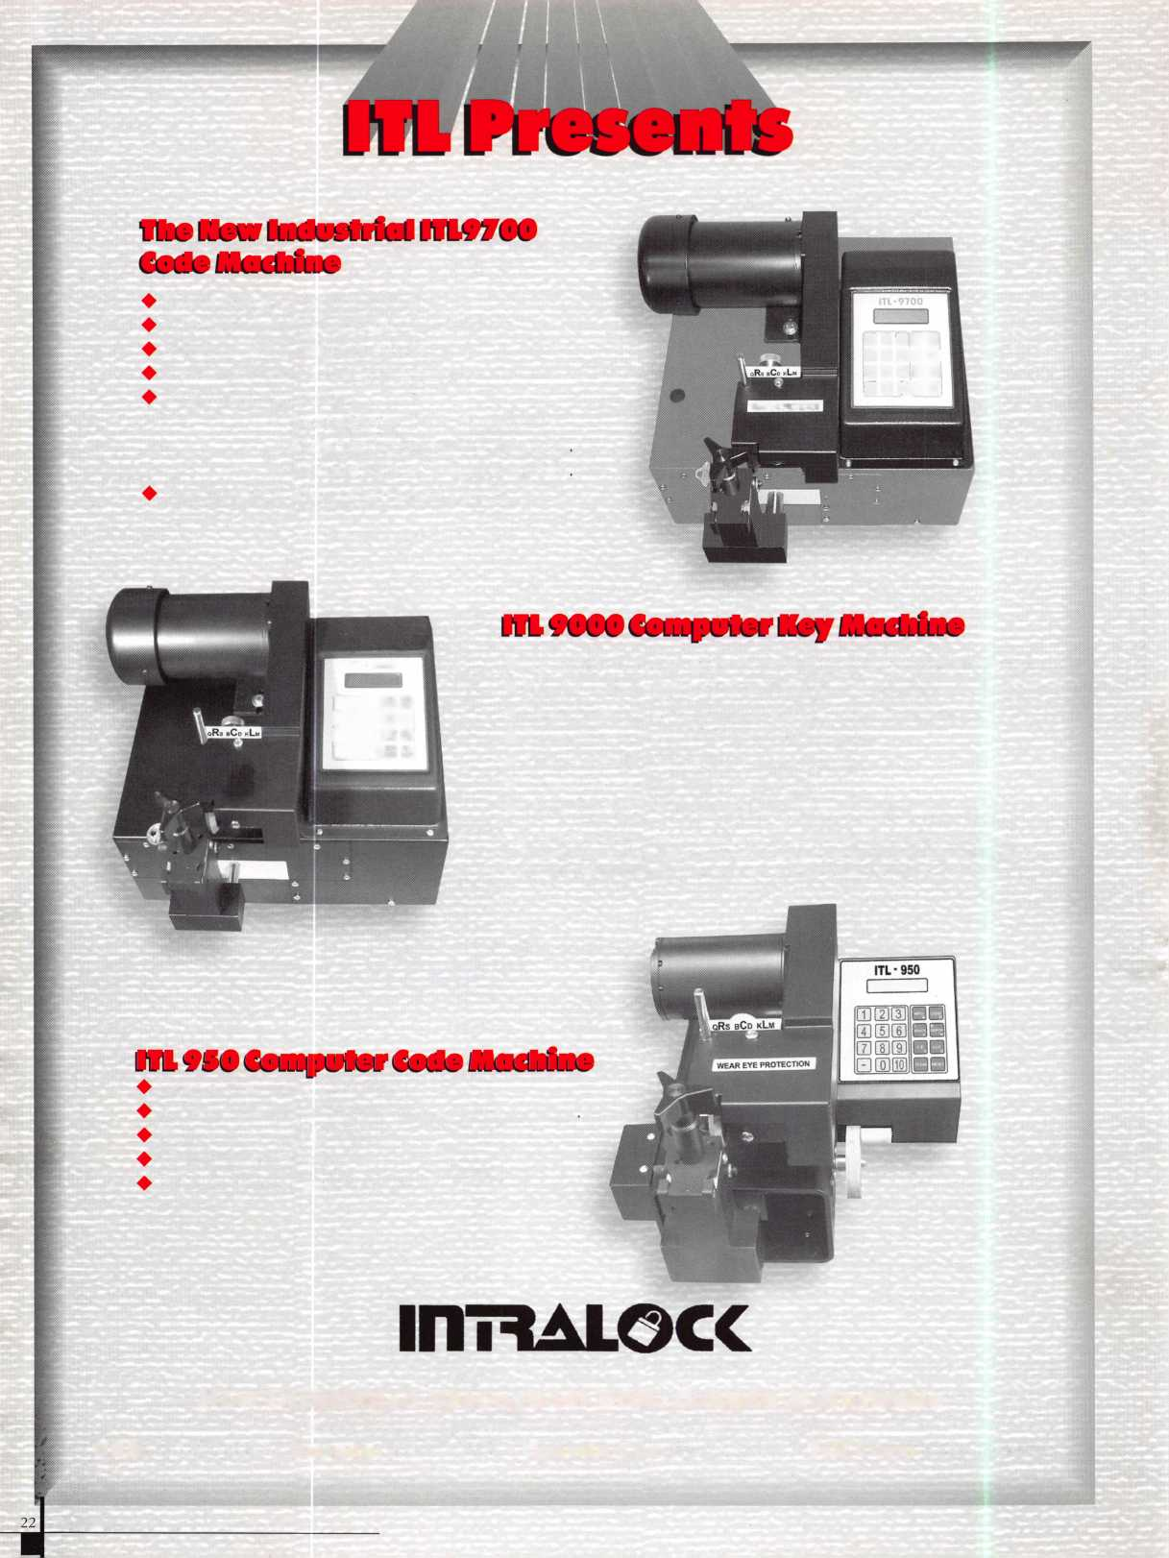

By John C. Whatley

Are you old enough to remember the “good old days” of automobile security? Back in the good old days (that’s before the 1900’s) a lost car key was no problem. Pop open the side vent to get in or use a coathanger, hot-wire the engine to drive, or use one of the many “extra” keys you had made. Sometimes a car key from another car, even another manufacturer, would work, but when cars got to be as expensive as your parents’ first house, security became ever more important. Today the key is the most important thing.

Beginning in the 1990’s automobile manufactures answered the public’s security demands with internal security. Side vents disappeared when solid side- window designs were adopted.

Flush internal car locks eliminated coathanger entry. Computer chips were added to the keys, so cars without ignition keys wouldn t crank, thus eliminating hot-wiring. Extra keys became difficult to get because of the specialized computer chips in them. And 10 or 12 computer modules in the cars controlled access at the door and at the engine. Suddenly locksmiths seemed to need degrees in computer engineering just to open a car door.

When there is a need, though, American ingenuity always finds a solution. Providing solutions for Ford-manufactured products (Ford, Mercury, Lincoln and Mazda B Series trucks) is 90-year old Hickok Incorporated of Cleveland, Ohio, an authority on the design and implementation of electronic security. Its major focus is the manufacture of diagnostic tools

for automotive electronic systems. Harry DeBevec is a 14-year veteran at Hickok and is Manager of Research and Applications, the peo­ple who develop scan tools for Ford.

If automobile security today is as tough as it sounds, how does his company get the information to rekey a car? “We’re not trying hit-or-miss solutions in the lab,” DeBevec said. “The automobile manufacturers give us the information.” In fact, his company designed the Ford scan tool (New Generation Star or NGS) for Ford Motor Company. Ford originally installed its own security system in the 1996 Mustang,

Taurus and Sable. Then Ford installed a more sophisticated system in 1998 and upgraded it again in 2000.

“Every manufacturer-GM, Daimler/Chrysler, Toyota, Volkswagen, etc.-has its own system, and its own scan tools, but the functions are basically the same: derivability. Every time a new car model is added, new modules are added, and every time a new module is added, the software is updated.”

Diagnostic scan tools are designed for the locksmith to communicate directly with the modules in the automobile. Each module has its own programming, but the scan tool forces the car modules to accept a new key. Powered by the car’s electric system, the scan tool “talks” with the modules in the car and “convinces” them to accept the new key, essentially “amending” the security programming. Thus the new key works well as the old.

Most of the scan tools are already in the field with the car dealerships. Outside of the dealer­ships the biggest purchasers are still locksmiths. Doesn’t that reduce rather than enhance security with all the scan tools out in the public sector? “It’s a toss-up between total security and cus­tomer service,” DeBevec continued. “Security is with the manufacturer and customer service is with the dealers and locksmiths. A middle ground gets reached. There’s still no

real security risk as such, at least no more so than before with mechanical keys and locks.”

DeBevec sees other changes coming in the future. “The reduced number of extra keys allowed per vehicle-only 8 or 16-was a handicap to police departments, taxis and other fleet users. Soon you will be able to make an infinite number of keys. Another change will be voice recognition. You won’t necessarily be able to say ‘Open sesame’ to your car door, but you’ll be able to open your trunk with a voice command.”

“Automobile security today is very similar to access control in business,” he continued. “Some companies have access cards, others have fingerprint control. High security areas use scanning lasers to identify retina patterns. In the future we may see pads on the auto that will read fingerprints. It may even be in development right now.”

“Today’s security systems are still hard to break into,” DeBevec con­cluded. “You can’t hot-wire this one.”

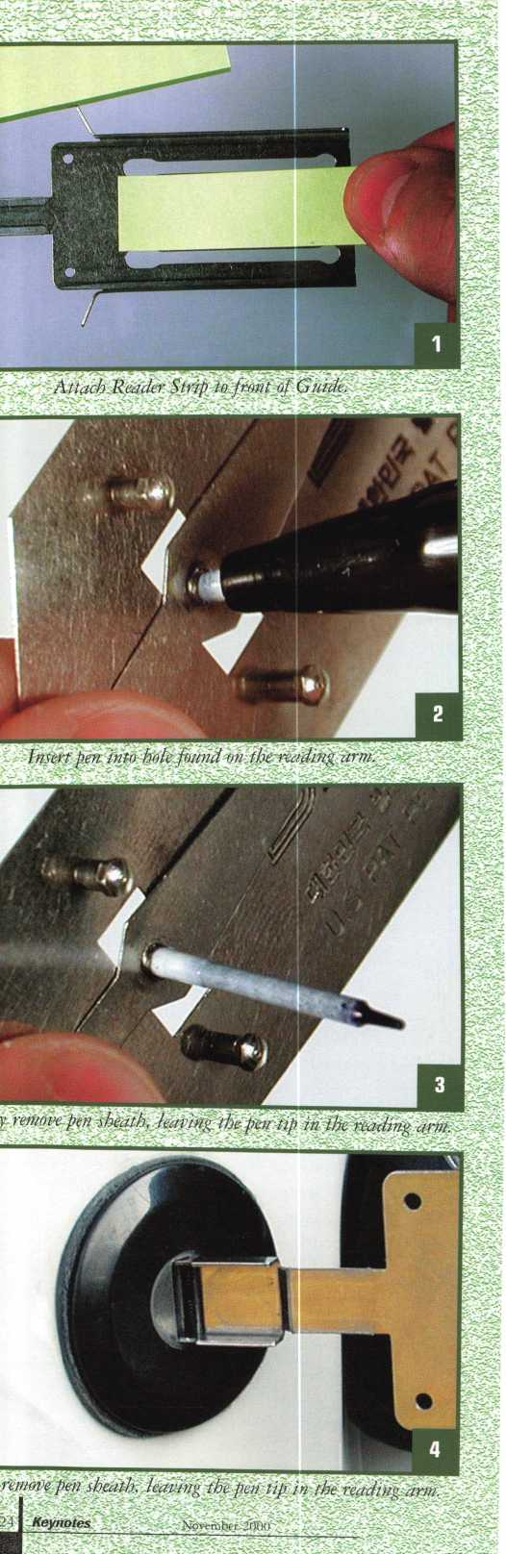

Reading A Lock With  
the SKT Reader

By Tom Seroogy

Looking more like the entrance to a carnival sideshow than a show booth at the 2000 ALOA Convention, I had to see for myself what was causing all of the commotion. Squeezing up towards the front, I expected to find what was probably the best pitchman since Ron Popeil, and a product to match.

Breaking through to the front line, however, instead of finding a hyper salesman waving collapsible fishing poles or cans of spray-on hair, I found an intense and silent tool demonstration.

The tool? SKT’s Wafer Reading Kit.

The reason for the crowd? The tool claims to be capable of reading an automotive lock without disassembling or removing the lock.

Having more than 13 years of automotive experience behind me, I’m quite familiar with tools holding similar claims, and welcome, as well as challenge, any new tool that makes my time on the road a little easier.

So, after having used H.E. Mitchel’s EZ-Reader and the Determinator with much success, I decided to check this tool out. Following is a demonstration of the tool’s performance. The target vehicle is a 1996 Ford Ranger. This particular vehicle uses Ford’s 10-Cut system. To generate a key, we’ll first generate a door key - using the SKT reader - and then progression the ignition lock.

Before beginning, it should be noted that the SKT reader was introduced at the 1999 ALOA convention, and drew a similar crowd. Unfortunately, that year’s release of the tool was not designed with domestic North American vehicles in mind (i.e. Ford, GM, Chrysler, etc.), and many locksmiths became frustrated with the tool.

Between 1999 and 2000, SKT, in collaboration with Saber Tool Company, made minor changes and added an extensive service manual to the tool kit to accommodate the North American locksmith market. This is the tool kit I tested.

Insert the Setting Blade to clear and prepare the lock

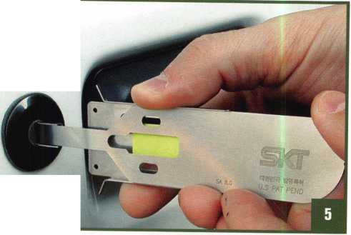

Before beginning, it is important to choose the correct components and correctly set the reading tools up before attempting to read the lock. The manual spells out clearly exactly how to choose and assemble the correct pieces. (Actually, once I understood how the tool worked and became familiar with all the components in the kit, it was easy enough to determine the parts needed without using the manual.)

There are five parts needed to read the lock - the Reader, the Setting Blade, the Reader Strip, the Guide and a pen.

To set the tool up, first take a Reader Strip and place it on the face of the Guide. As the Reader Strip is simply a small stickup note, it fastens easily to the front of the Guide.

(See photograph 1.)

To prepare the Reader, place the tip of the pen into the pen-tip hole found in the Reader’s reading arm. (See photograph 2.) To fasten the tip into the arm, apply light pressure on the tip while turning clockwise on the pen.

Once the tip has firmly engaged the hole, continue rotating the pen while pulling the pen sheath up and off of the pen tip. (See photograph 3.)

We’re now ready to read the lock.

Insert the Guide into the lock’s keyway. The Guide opens the lock’s shutter unit, allowing unhindered access for the Setting Blade and Reader. (See photograph 4.)

With the Guide in place, insert the Setting Blade to lifting the tumblers out of the keyway and making a clear path for inserting the Reader. (See photograph 5.)

After aligning the tip of the reading arm at the center of the Reader’s tip (see photograph 6), insert the Reader fully into the lock until it is fully seated. (See photograph 7.)

Holding both the Guide and Reader in place, gently pull the Setting Blade out of the lock and from between the Guide and the Reader. (See photograph 8.)

With the Setting Blade removed, assemble the Reader to the Guide by mating the guide bolts on the back of the Reader with the guide slots on the Guide. In some instances, it is necessary to pull the Guide out of the lock to properly align and engage the guide bolts with the guide slots. While doing so, make sure that the Reader remains fully inserted in the lock. Once the Reader and Guide are assembled, move the Guide back into the shutter door. (See photograph 9.)

■i

«****,»

Aligning the reading arm at the center of the Reader's tip prevents it from becoming damaged as the Reader is inserted into the lock.

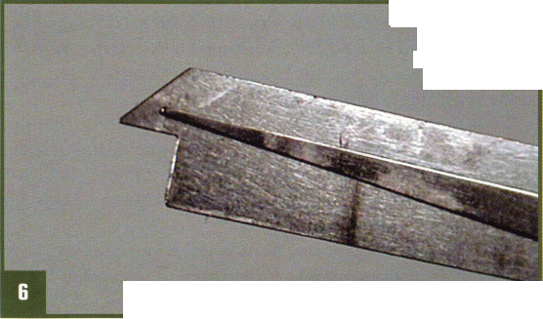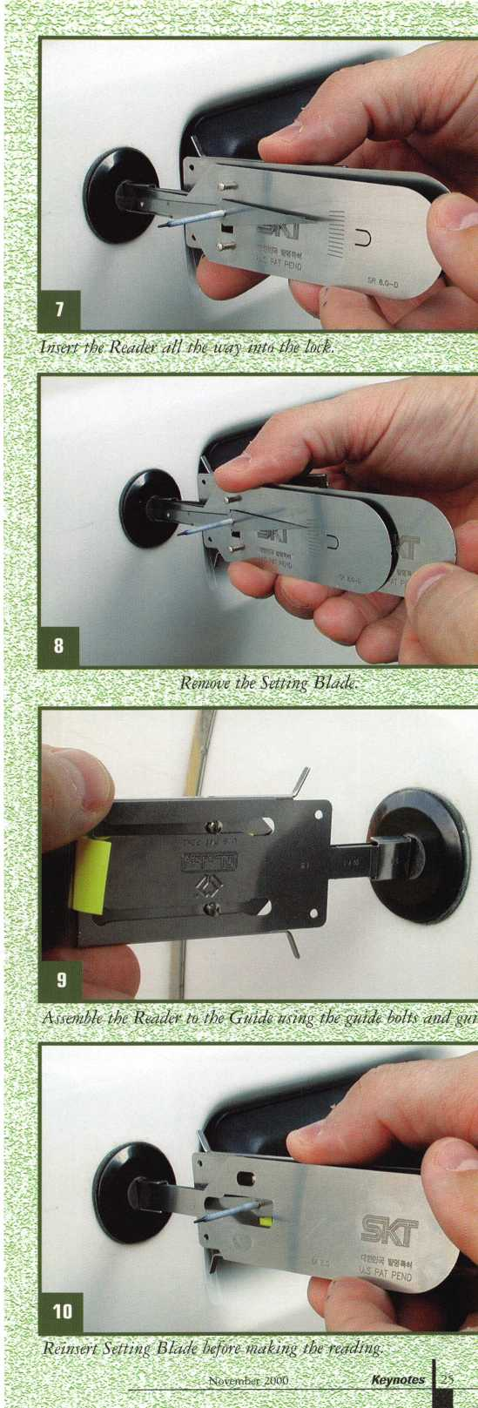

With the Reader and Guide ready for reading, insert the Setting Blade one last time. This clears the keyway, and straightens the Reader in the keyway, allowing for better reading results. While inserting the Setting Blade, make sure that you do not hit the pen tip. This is easily accomplished, as both the Reader and the Setting Blades are extremely flexible. (See photograph 10.)

Square up the Guide and Reader assembly with the face of the lock. To obtain the best results, it is critical that the assembly be square during the entire reading procedure. We’re going to lift and drop the reader arm a couple of times to make sure that the arm moves freely and to create an index mark on the Reader Strip. As this the Ford 10-Cut key system is a tip stopped or tip gauged system, the index mark is later used as the reference point for reading our markings with the Reader Gauge. On shoulder stop key systems the last sharp drop on the Reader Strip indicates the shoulder position. (See photograph 11.)

Now, keeping the Reader/Guide assembly square, slowly and gently pull the Reader out of the lock. The slower the better. Rapid removal causes the reader arm to jump, rendering inaccurate readings. (See photograph 12.)

Pull until the Reader reaches the end of the Guide, or is fully removed from the lock. At this point, a diagram of the key bitting can be seen on the Reader Strip. (See photograph 13.)

For this article, I used the Reader Gauge to read the depths left on the Reader Strip. After a few tryouts with the tool, I was able to sight read the Strip and the gauges were not needed. (See photograph 14.)

With the test complete, how are the results? Well, it should first be stated that like all the lock reading tools available, the SKT Wafer Reader is not a “Magic Wand.”

It is an “AID” for reading locks. Damaged locks or wafers, debris (especially grease) in the lock and your own competence and experience with the tool all lend weight in determining your degree of success and/or failure with this reader.

A beginning locksmith may find this tool attractive, but (just like any tool) having an understanding of locking principles and locksmith techniques is absolutely critical for satisfactory results.

As for some of the positive and negative aspects of this tool:

On the negative side, if not handled correctly, the pen may pose some hindrance in colder climates. And, at the time of this article, this tool is not able to read Toyota’s split wafer system. (The Reader gets jammed between the wafers. I’m told that a separate reader for the Toyota split wafer system is in the works.)

On the positive side, this single tool seems to be able to read just about all vehicles with standard wafer locks - ideal for Ford, GM and Chrysler, as well as most imports - with­out having to add an update or new tool every time a new vehicle or key system is introduced.

For more information on the SKT Wafer Reader, take your web browser to [www.lockmasters.com](http://www.lockmasters.com), or contact Lockmasters at (800) 654-0637.

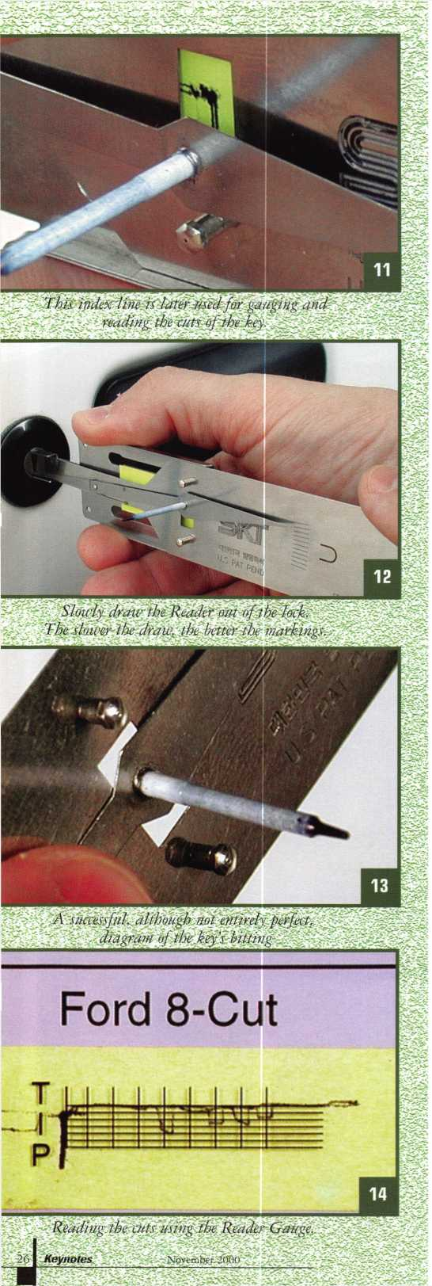

The **2000** edition of Steve Young’s Quick Entry Car Opening Manual

is ***now*** available!

If you’ve been looking for an ACCURATE and easy to  
use car opening manual, your search is over. Steve Young  
has personally disassembled hundreds of door panels to  
guarantee you that each opening method is the easiest and  
safest way to open the car. You can be sure that the methods

shown in this manual will work!

If you have ever met Steve Young, then you know why he is often referred to as “The world’s leading authority

on car opening.” Steve Young has built a reputation for providing accurate and reliable car opening information. The attention to detail in this manual continues that tradition.

You won’t find any catalog reprints, endless duplicate pages or advertising in our manual! That’s why we can give you all of the information you need in one volume while others want you to buy two or more volumes! Instead of wasting your money on fuzzy, hard to understand photos, the QuicK Entry Manual features clear, concise line drawings of each car door to show you where the linkages

SAMPLE PAGE (Reduced) Actual page size: 5.5” X 8.5”

VEHICLE: CADILLAC SEDAN DEVILLE (DTS), 2000 WEDGES: YES LIGHT: OPTIONAL TOOL: TT-1001

DIRECTION OF TURN: CLOCKWISE*

This vehicle is equipped with seatback-mounted side-impact airbags for both front and rear seat passengers as standard equipment. Because the airbags are mounted in the seatbacks there is no risk of damaging the airbag with car opening tools. The vehicle can be unlocked easily through the REAR DOOR.

Begin by wedging open a gap at the base of the main window of the REAR DOOR as far to the rear as possible. Before inserting the tool into the door, compare the length of the tool to the position of the outside door handle, so that you can tell when the end of the tool is at the same level as the handle. Insert the tool into the door, as far to the rear as possible, and then lower it until the tip is at least as deep as the outside door handle. Rotate the tool so the hook is pointed toward the inside of the car and then pull up on the tool. The tool should now be hooked around the inside lock control linkage rod. Twist the handle of the tool in orderto bind the linkage, then lever the linkage rod forward to unlock the door. If you have trouble locating the linkage rod, an inspection light can be inserted into the door and the linkage rod can be located visually.

'Direction of turn for driver side only. Passenger side has noigstcyimdEf.

Page: USA 149-

COPYRIGHT © 2000 STEVEN E YOUNG

“I *personally guarantee*

your complete  
satisfaction or your  
money back! ”

Steve Young, Owner  
Tech-Train Productions



and guards are located. You also get a step-by-step  
explanation of how to open each car, plus the direction  
of turn to pick the door lock. Alternate methods are  
included for hundreds of vehicles so that you’re not  
limited to one method or tool. Warnings are printed in  
bold print to alert you to potential problems with  
particular vehicles. This manual makes car opening easy  
for both beginning and experienced locksmiths!

The Quick Entry Manual

is the perfect companion for

EASY TO UNDERSTAND  
“CUT-AWAY” STYLE  
DRAWINGS SHOW YOU  
WHAT’S INSIDE EACH  
DOOR!

EXCLUSIVE TECH-TRAIN  
DIFFICULTY INDEX TELLS  
YOU HOW EASY EACH

VEHICLE IS TO OPEN!

QUICK-REFERENCE

HEADING FOR EACH CAR  
QUICKLY GIVES YOU THE  
IMPORTANT INFORMATION  
YOU NEED TO  
UNLOCK THE CAR!

EACH VEHICLE IS EASY TO FIND WITH OUR ALPHABETIZED INDEX OF - OVER 500 DIFFERENT VEHICLES BY MAKE AND MODEL YEAR!

your Tech-Train tool set, but this is one manual that can be used with anyone’s tools. Because the Quick Entry Manual shows you where the linkages and guards are located, you can use other tools that you already own!

The 2000 Quick Entry Manual and manual updates are available directly from Tech-Train and Security Resources, Inc. Order your Quick Entry Manual risk free today for only $89.95 plus $7.00 shipping and handling. Owners of our 1999 manual should call (800) 3 5 6-013 6 for a special offer and to order their 2000 update as soon as possible.

We guarantee complete satisfaction or your money back. Wouldn’t you like to own the most complete and accurate car opening manual in the world?

ORDER RISK-

**YOURS f5rE TODAY! only...**

P,US shlpping PRODUCTIONS Call (800) 356-0136 today RO, BOX 15401

for our FREE catalog! PENSACOLA, FL 32514

U

November 2000

Keynotes

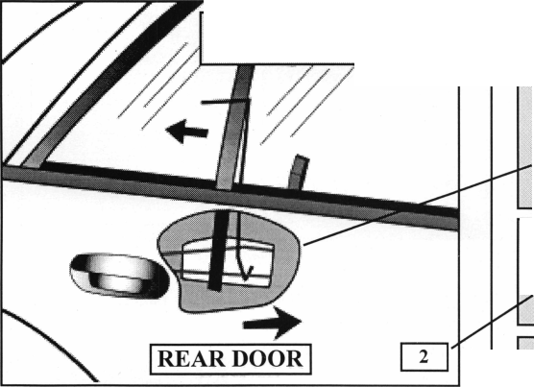

The National Locksmith Guide

to Motorcycles on CD

This is another technical  
book from The National  
Locksmith to become  
available on CD. Guide to

Motorcycles is authored by John

Blankenship. If you already have the

by Sal Dulcamaro, CML

few pages and get to the table of contents page, you can click on specific chapters by way of hypertext (sort of the way you would jump from one place to another while on the internet) and go to specific pages of the book. You can also use the index that I mentioned earlier on the left side of figure 1.

printed edition of the book, you have all the includ­ed technical information. There are, however, a number of interesting features that you gain from the CD ver­sions of the various technical books from The National Locksmith. They come in PDF format, and the CD includes a copy of Adobe Acrobat Reader, which is

Table of Contents

3 Key information  
3 Progression Charts  
BMW

H31997 R1100R  
B-f|| Harley- Davidson  
I—Ol 1938 Knucklehead  
-31870 Sportster  
j—Q1980 8portster  
**!J1984** Wide Glide  
4319944 T«bul3r Iflnition  
E3”Q Honda

31968 Mini Trail 50

UfJ 1970 Trail 90  
i-f§1971 CB750  
H31978CB750  
| 31978 Hawk

| 31981 CB900  
J1982 Ascot  
r~31983 Shadow  
I - 31984 Nighthawk  
431995 Rebel

- □1990 Gold Wing ^

hi ,

**M**

**Quide** to

*'*

torcycles

by |«br> btankenahip

.. r:r rr4I nI12!Iu5iJ IE

Figure 1

required to view the CD book on your computer. This  
particular CD has Adobe Acrobat Reader version 4.0. I  
know some of the earlier issued CD books had version

3.0. A sample of what you might  
see on your computer screen is in  
figure 1. To the left is an index of  
sorts, while a picture of the book’s  
cover can be seen at the right.

There are a couple of places on the  
screen where you can place your

cursor on arrows (and click) to go forward or back  
through the pages of the book.

There are a number of ways to navigate through this electronic book. You can click on the arrows, as indicated earlier, or select specific locations through the different index “pages”. If you advance with the arrows a

□

3 Progression Charts

- 3 BMW

431997 R1100R

4_J Hartey-Oabwteon

- 3193eKnucM«h8ad

31970 Sportster  
431990 Sportster  
31984 wide Glide

\ySSSBMSMBBt

43 Honda

Besides jumping  
the ability to change  
your level of magni-  
fication to enlarge  
words or graphics as  
needed. There are a  
number of search  
functions that allow

Figure 2

**H6**

avid son **1994**\*

Ignition Lock

Figure 3

about to various pages, you have

Keynotes

November 2000

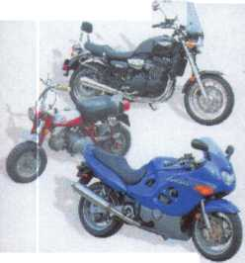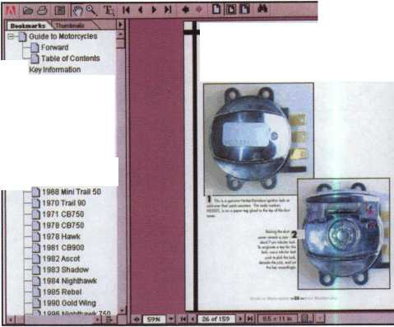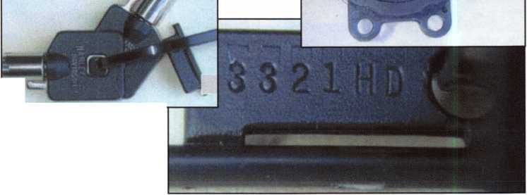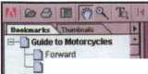

you to find specific information that may not be specifically identified in any particular index.

It can search for a word or phrase, and show you each location where they show up.

Now I’ve explained how you use Adobe Acrobat Reader to look through this particular electronic book, but that would be pretty much the same as anything else you view in pdf format. Let me com­ment on the content. Obviously, the technical content is the same as the printed book, so most of what I indicate will apply to both the printed and electronic versions. The quality of the graphics and pho­tographs is excellent. The images are mostly (if not all) in color.

With about 150 some pages, it cov­ers quite a few motorcycles. There are servicing and disassembly instructions, plus code location information. The actual codes you will have to find in a code book or program, but spacing, depth and key blank information is also included.

Figure 2 shows highlighted information on the index at the left. Under “Harley-Davidson” I selected “1994+ Tubular Ignition Lock”. It called up page 26 of 159 at the right as the graphic. Now because even the cover has to be assigned a page for Adobe Acrobat Reader to find it, you will see a slightly different page identifica­tion on the printed version (or hard copy). Although it may not show up very clearly, this is page 22 from the book. The photo labeled #1 is a Harley tubular ignition with the dust cover concealing the lock. The photo labeled #2 shows the dust cover up, exposing the tubular lock. Depending on the computer that you use and the resolution of your monitor, the image quality may vary. If you have high resolution capability, you should get excellent image quality.

If you need greater detail, you can always enlarge the image.

You also have the option of printing pages. You can either make a full hard copy version of the book or print pages individually. This, again, will be affected by the overall capabilities and quality of the equipment you have. I recent­ly bought a photo quality color printer, and figure 3 shows a full page reproduction of the next page (page 23) to the one shown in figure 2. I found it to be of excellent quality, and a near perfect recreation of the original page.

It is my impression that if

you are interested in Motorcycle locksmithing, you will probably like both the printed and electronic versions of “Guide to Motorcycles” by John Blankenship. I’m person­ally leaning toward the electronic (CD) version, because technically it can be both. You can turn it into hard copy any time you wish, but doesn’t take as much space if you don’t choose to print it. For additional information, contact The National Locksmith at: 630/837-2044.

You can find them online at: [www.thenationallocksmith.com](http://www.thenationallocksmith.com)

“If you want to study for the CPS test,

you need this book.

Without that book, I wouldn’t have my certification.”

-Dennis Johnson, CPS Aurora\, Illinois

The Safe

Technicians  
Reference Manual

"Mike's new book is very consistent with the study information required to pass the SAVTA/ALOA CPS certification test. I wouldn't have passed without it. A tremendous resource for today and tomorrow..."

-John T. Grist, CML, CPS North Georgia Security

"The Safe Technicians Reference Manual  
by Mike Oehlert ranks among the best

technical reference and learning aids you will find in the safe and vault  
industry. It contains page after page of essential information and easily  
understood illustrations. Besides answering most of the questions commonly  
asked by technicians new to the field, Mike has also included plenty of

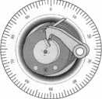

information experienced technicians will find useful."

-Ken Dunckel Pacifica, California

■►Over 600 Illustrations.-*

320 pages. Only $135.  
What are you waiting for?

To order, call 800-532-2562. Allow 3 weeks for delivery.

All major credit cards accepted; or make check payable to ALOA.

November 2000

Keynotes

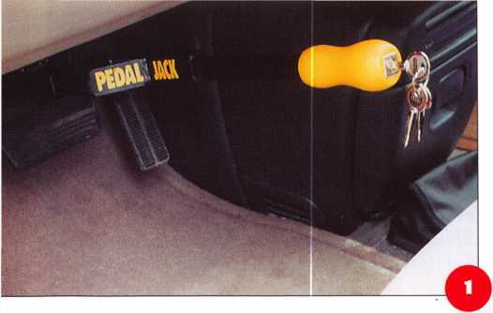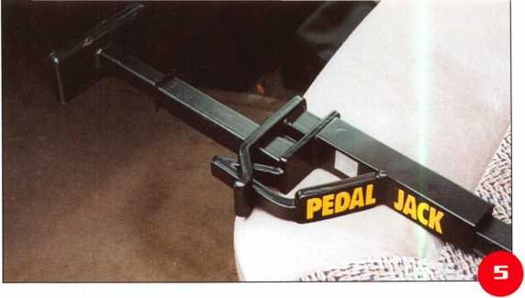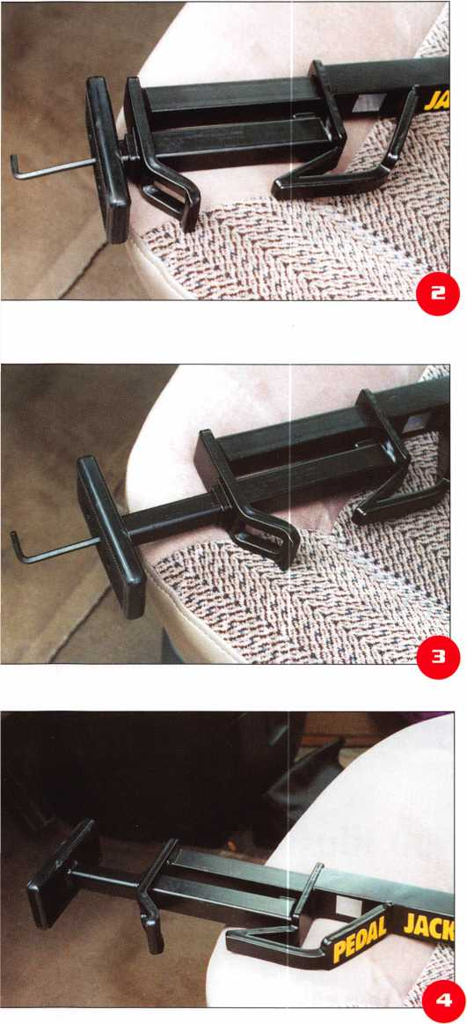

The Pedal Jack

by Sal Dulcamaro, CML

The Pedal Jack is an interesting new auto security device. It is designed to overcome the many weaknesses of the various types of steering wheel locking devices such as the Club and its various imitators. It is attached to something much stronger than the steering wheel— the brake pedal shaft. The standard version of the Pedal Jack is designed to both lock and block the brake pedal (for vehicles with automatic transmission) to prevent it from being depressed, and not allowing the car to be put into gear. Photograph 1 shows the Pedal Jack securing the brake pedal. It is tightly wedged against the floor below the dash board on one side and underneath the shaft of the brake pedal on the other side.

Universal and Fully Adjustable

The Pedal Jack is adjustable to fit properly regardless of the type of vehicle. Photograph 2 shows an Allen wrench protruding from the bottom end and fitting into the female hex shaped opening of the adjusting screw at the bottom of the Pedal Jack. It can be expanded (lengthened), as in photograph 3 to adapt to the different amounts of space under the brake pedal shaft. You may need to shorten or lengthen the Pedal Jack when using it with different vehicles (cars, trucks, etc...). With the device properly lengthened in photograph 3, it is possible to slide the device into position and place the lower hooked end underneath the shaft of the brake pedal. Pulling the yellow handle outward engages the

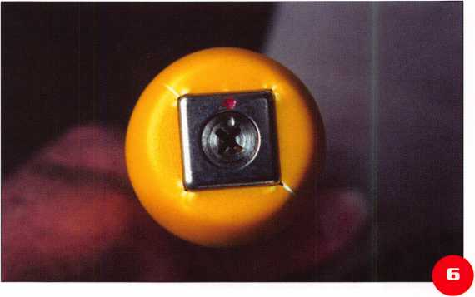

November 2000

***Keynotes***

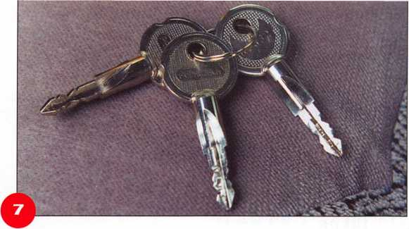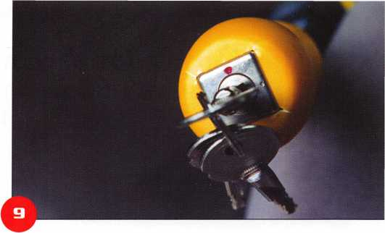

ratcheting action until both lower and upper hooked ends come together and lock the shaft of the brake pedal between them. Photograph 5 shows how it comes together, as a demonstration, without being attached to the brake. If it was, the brake shaft would be locked into place and couldn’t be moved.

The Cruciform Keyway

Photograph 6 shows a closeup of the cruciform (cross shaped) keyway. It resembles the letter “X”, and has pin tumblers extending from four directions (although not clearly visible in the photograph). The key can only be inserted one way, being that some of the legs of the “X” are wider than others. To avoid confusion for key insertion, a dot is visible on the face of the cylinder plug that coincides with an arc shaped notch on the key. A separate dot can be seen above the dot of the plug (on the face of the lock shell) identifying the locked position. The three included keys are shown in photograph 7. The key is cut on all four surfaces of the cross shaped key. The positioning notch on the bow of the key(s) is fairly apparent.

In photograph 8, the key has been inserted. The notch on the key is aligned with the dot on the plug. The dot on the face of the shell surrounding the plug indicates the device is still locked. When rotated clockwise one quarter turn, in photograph 9, being aligned with a smaller dot on the face of the shell indicates the device is unlocked. The handle could be pushed inward, which would release the brake and allow the Pedal Jack to be removed.

The Pedal Jack is made of heavy duty tempered steel to resist sawing or bolt cutters. It has a patented high security lock cylinder, with a tempered steel plate to make it drill resistant. Duplication of the keys is supposed to be

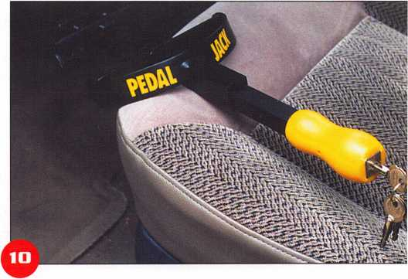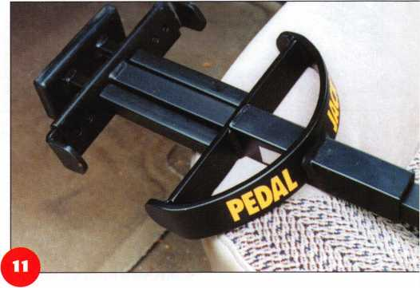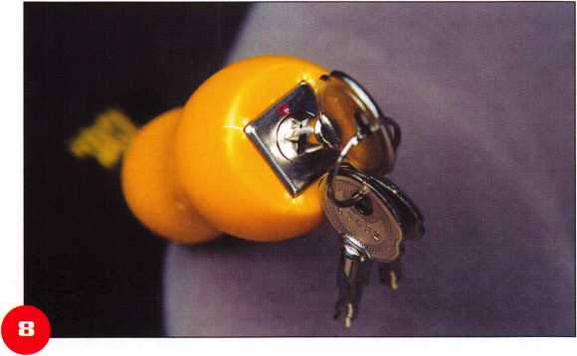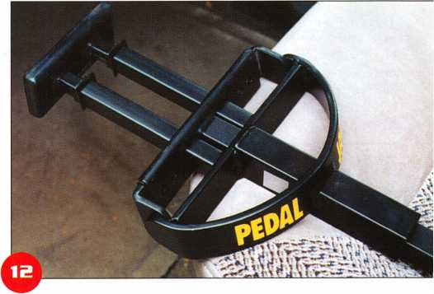

November 2000

Keynotes

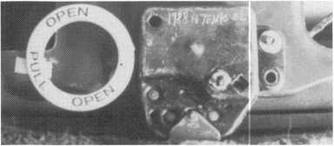

*

* “Quick-Out” Emergency Trunk Release

Prevent Tragedy - Install a “Quick-Out” Device Today

Fits Virtually All Model Autos

QUICK-OUT INSTALLED

Easy to Install

A Child Can Easily Release the Trunk Latch from  
Inside of the Trunk to Escape

Federal Law in new vehicles. A must for all others.  
In packs of 10 FREE Window Poster

$11.00 ea + $3 S&H

EASY ESCAPE

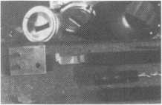

The Innovator

1998 and up GM in-dash ignition removal kit.

Patent 5,454,245

Removes plastic ring and chrome cap in seconds; makes access hole to pick side bar; turns cylinder to ACC position.  
Removes lock in less than five minutes with no damage to lock. Your first job will more than pay for the kit.

Introductory price: $70.00 + $4 S&H



1996 and up 8-Waffer Ford Ignition  
Removal Kit and Side Bar Breaker Tool

Patent 5,701,773

Turn ignition to “ON” position in less than 60 seconds for fast removal or use kit to

push side bar in, then turn cylinder to “ON” position without any damage. Fit key, replace same lock. Or use the force tool to  
turn to “ON” position for fast removal in 60 seconds; no damage to waffers. $90.00 + $4 S&H

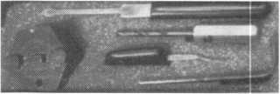

■ FINISHED CYLINDER

1994 and up 9-Waffer GM Ignition Removal

Patent 5,454,245

A new system for the future. These locks have side bars longer than the old type and must be in  
the “ON” position to remove the cylinder. My tool will do this. Best of all, you will not damage

the cylinder. You can repair, fit key and replace the same cylinder. Do only one job and you will have the price of the kit paid for. A  
replacement cylinderxosts,about $22.00, VATS $45 our cost. Order one today at my special introductory price, and be prepared for  
these new locks. $60.00 + $4 S&H. ***Upgrade it for ’95 Blazers, Suburbans, S-10 Pickups, etc. $20.00 + $4 S&H***

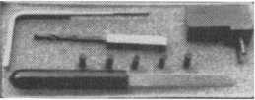

Tool Kit

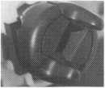

FINISHED CYLINDER

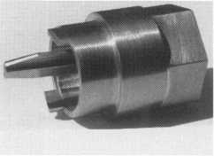

Ford “Quick On”

Patent 5,454,245

Now turn all 10 cut ignition cylinders to the “ON” position for fast removal - in less than 60 seconds. Sable, Taurus, all styles, even with airbags. No damage to housing.

**$65.00** + $4 S&H

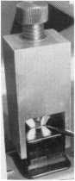

No-Nonsense Squeeze Lock  
Plug Remover

Patent 5,165,158

Now you can remove all squeeze lock plugs in 15 seconds  
or less, from all GM, Ford, Chrysler, AMC, Jeep, no more  
fumbling, gadgets, cut fingers, broken tabs, need for 3  
hands for removal of lock. It’s so easv. you can do it in the  
dark, while it’s still in the glove box. $45.00 + 4 S&H

The GM Persuader

This unique tool will open virtually all GM trunks and doors, through the current year, where tool fits into the cylinder core cavity,  
in less than 50 seconds. No drilling, pulling, picking, special tools, or electric needed. When customer’s key does not open trunk  
because: Problem 1: spring retainer popped up into outer shell; Problem 2: one side of side bar sprung off side bar

does not retract; Problem 3: key or cylinder worn side bar does not retract; Problem 4: key jammed in lock in  
“turned” position, etc. With The Persuader you will open these locks in less than 50 seconds. No damage to lock, just  
repair and replace, nothing to wear out. Yes, if needed, it will open with no key.

Note: because of The Persuader’s capabilities, it will be sold to locksmiths only. $45.00 + $4 S&H

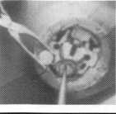

Ford Disc-Out Kit

Patent #4,682,398

A tool kit to remove those stubborn Ford pin ignition locks from 1976 through the current year. These locks incorporate 2 locking  
devices and a hard steel disc across the shear line. They must be in the “ON” position, to release both locking devices, so as not to  
damage the housing. I guarantee the job to take 5 minutes with my kit. Complete Kit $55.00 + $4 S&H

Aable Locksmiths • 86-19 97th Avenue • Ozone Park, NY 11417 • 718.847.1377 • Fax 718.847.0991  
Frank Markisello guarantees all of his products to do as stated or your money back!

Keynotes

November 2000

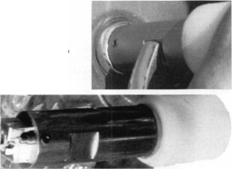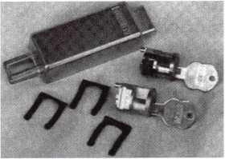

restricted. The Pedal Jack can be engaged with the hook ends on either side of the brake pedal shaft. This makes it more comfortable to use for right or left handed people. The ratcheting action of the device allows it be engaged without using a key. Merely position it and pull outward on the handle until the device is fully engaged and tight. Releasing requires only inserting the key and turning. The device is key retaining, so you cannot remove the key when it is turned to the unlocked position.

Pedal Jack for Manual Transmissions

Photograph 10 shows another version of the Pedal Jack designed for vehicles with manual transmissions. The bottom end, in photograph 11, reveals how it is made to engage both the brake and clutch pedals at the same time.

Like the version for automatic transmissions, pulling on the handle grabs and secures both shafts (for brake and clutch pedal). Photograph 12 shows how the parts close together.

Like the other Pedal Jack (for automatic transmissions), the length can be adjusted to accommodate more or less space below the brake and clutch shafts. Photograph 13 shows the Allen wrench adjusting the length on one of the two legs. Both sides must be adjusted when changing length. Because it locks two separate shafts, there is an additional adjustment for width (or spacing) between the two shafts. Photograph 14 shows one of the two plates being adjusted outward to accommodate a wider spacing between the shafts.

Product Availability

The suggested retail price for the Pedal Jack for automatic transmissions is $34.95. The manual transmission version lists for $39.95. For additional infor­mation and availability, contact: Unelko Security Systems LTD., 14641 N. 74th Street, Scottsdale, Arizona 85260. Phone: 602/991- 7272. FAX: 602/483-7674.

Internet address:  
[www.unelkosecurity.com](http://www.unelkosecurity.com)

November 2000 Keynotes

SECURITy

LOCK COMPANY

**New** Factory Replacement  
Parts and Locks for Security  
Corporation and Kumahira  
Safe Co. Products

* Safe Deposit Box Locks  
  and Parts BX, KD
* Automatic Remote  
  Tube Systems (ARTS)
* Drive Up Systems
* Vault Doors
* Night Depositories
* Camera Systems
* Key Blanks and
* Keys Cut to Code

SECURITy

LOCK COMPANY

KD Series

Safe Deposit Box Locks

BX Series Safe Deposit Locks

1155 Chess Drive, #114 Foster City, CA 94404 Phone: (650)525-0660 Fax: (650) 525-0444

Email:

[chaslutz@securitylockco.com](mailto:chaslutz@securitylockco.com)

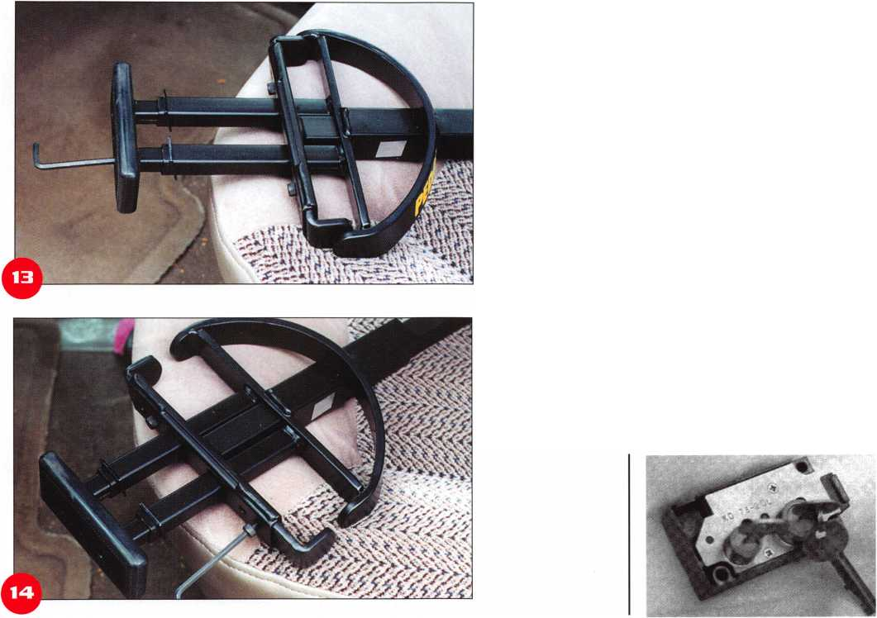

by Tim McMullen

LEGISLATIVE WRAP-UP

BELOW IS THE LISTING OF BILLS ALOA TRACKED DURING THE 2000 LEGISLATIVE SESSION:

ALABAMA S91

INTRODUCED: 02/01/2000 SUMMARY: Relates the Alabama Sunset Law; continues the existence and functioning of the Alabama Electronic Security Board of Licensure with certain modifications; clarifies the exemption of any person of business entity that only sells alarm systems at the premises of a customer, but does not enter the premises, or install, service, or respond to alarm system at the premises.

STATUS: 03/21/2000 Signed by GOVERNOR.

CONNECTICUT H5849

INTRODUCED: 03/02/2000 SUMMARY: Requires the licensing of locksmiths.

STATUS: 08/25/2000 2000 Regular Session of the General Assembly Adjourned - 05/03/2000 - No Carryover.

IOWA H310

INTRODUCED: 02/18/1999 SUMMARY: Provides for the mandatory licensure of alarm system businesses by the department of public safety, and makes many of the provisions of Code chapter 80A, which applies to the licensing of private investigative agencies and security agents, applicable to an alarm system business.

STATUS: 06/22/2000 78th General Assembly — Second Session Adjourned - 04/26/2000 - No Carryover.

ILLINOIS H1296

INTRODUCED: 02/17/1999 SUMMARY: Makes technical changes in the Section concerning unlawful acts in the Private Detective, Private Alarm, Private Security and Locksmith Act of 1993.

STATUS: 03/05/1999 Rereferred to HOUSE Committee on RULES.

34 | KeynotesNovember 2000

ILLINOIS H3479

INTRODUCED: 01/20/2000 SUMMARY: Relates to licenses; amends the Private Detective, Private Alarm, Private Security, and Locksmith Act of 1993; makes a technical change in a Section concerning temporarily suspending a license.

STATUS: 01/20/2000 To HOUSE Committee on RULES.

ILLINOIS H62T

INTRODUCED: 02/04/1999 SUMMARY: Provides that police, fire, or other municipal employees may open a lock when a diligent effort has been made to contact a licensed lock­smith who can provide the service in a timely manner as determined by the police, fire, or other municipal employee. STATUS: 03/26/1999 In HOUSE. Withdrew Amendment No. 2. Read second time. Adopted Amendment No.l. Placed on Calendar Order of Third Reading. Rereferred to HOUSE Committee on RULES.

ILLINOIS S212

INTRODUCED: 02/03/1999 SUMMARY: Makes a technical change.

STATUS: 03/20/1999 Rereferred to SENATE Committee on RULES.

ILLINOIS S452

INTRODUCED: 02/18/1999 SUMMARY: Provides that the 3 years of experience required for licensure as a private detective may be employment as a full time investigator for a licensed attorney, State's Attorney Office, or Public Defender's office; provides that an agency may employ a person who has a valid license under the act; opened grandfather period from September 1, 2000 to December 31, 2000.

STATUS: 06/13/2000 Signed by GOVERNOR. Public Act No. 815

KANSAS H2456

INTRODUCED: 02/10/1999 SUMMARY: Requires locksmiths to check identification of a person requesting services and to record

information relative to the transaction. STATUS: 08/28/2000 78th Legislature — 2000 Regular Session Adjourned - 05/24/2000 - No Carryover.

KENTUCKY H409

INTRODUCED: 01/20/2000 SUMMARY: Requires locksmiths to check identification of a person requesting services and to record information relative to the transaction. STATUS: 05/22/2000 2000 Regular Session Adjourned - 04/14/2000 - No Carryover.

MASSACHUSETTS S545

INTRODUCED: 01/06/1999 SUMMARY: Establishes a program with the Department of Housing and Community Development to retrofit windows with security bars.

STATUS: 07/15/1999 From JOINT Committee on HOUSING AND URBAN DEVELOPMENT:

MISSISSIPPI S2718

INTRODUCED: 02/11/2000 SUMMARY: Provides for the licensure and regulation of burglar or intrusion alarm system installers; defines certain terms used in the act; creates the Mississippi Electronic Security Board of Licensure; provides for its powers and duties; provides for an annual license fee; excludes certain person from the application of the act; provides for civil and criminal penalties for violations of the act. STATUS: 06/26/2000 2000 Regular Session of Mississippi Legislature Adjourned - 05/07/2000 - No Carryover.

MISSISSIPPI H439

INTRODUCED: 01/20/2000 SUMMARY: Regulates the installation and service of burglar alarm system; defines certain terms; creates the Mississippi electronic security board of licensure and provide for it membership and administration; provides the powers of the board; provides licensing requirements; provides exemptions from this act;



provides for violations of this act; provides for uniformity; provides for its administration.

STATUS: 06/26/2000 2000 Regular Session of Mississippi Legislature Adjourned - 05/07/2000 - No Carryover.

MISSISSIPPI H 1038

INTRODUCED: 02/18/2000 SUMMARY: Regulates and license the installation and servicing of burglar alarm systems; defines certain terms; creates the Mississippi and Electronic Security Board of Licensure; prescribes its membership and Administration; provides for the powers of the Board; requires licensing; requires fees; provides requirements for licensee; provides exemptions; provides penalties for violations of this act; provides for uniformity; creates a special fund. STATUS: 06/26/2000 2000 Regular Session of Mississippi Legislature Adjourned - 05/07/2000 - No Carryover.

NEW YORK A2099

INTRODUCED: 01/20/1999 SUMMARY: Allows for a 10% credit against income tax for businesses in Kings County which install security systems at their businesses.

STATUS: 01/20/1999 To ASSEMBLY Committee on WAYS AND MEANS.

NEW YORK A3889/A8242

INTRODUCED: 02/04/1999 SUMMARY: Provides that a taxpayer 65 years of age or over shall be allowed a credit against personal income tax for the purchase and installation of a security device in his principal residence located within the state; provides that such credit is limited to 50% of the expenditure not to exceed a maximum of $400.

STATUS: 02/04/1999 To ASSEMBLY Committee on WAYS AND MEANS.

NEW YORK A4095

INTRODUCED: 02/08/1999 SUMMARY: Establishes a Health Care Security Program including grants to eligible health care facilities to provide funding for costs to enhance security measures; increases medical assistance reimbursement rates for facilities in the program; appropriates funds therefor.

STATUS: 01/25/2000 From

ASSEMBLY Committee on HEALTH. To ASSEMBLY Committee on WAYS AND MEANS.

NEW YORK A4560/S2530

INTRODUCED: 02/11/1999 SUMMARY: Makes it a class A misdemeanor to knowingly possess equipment used to make duplicate keys under circumstances evidencing intent to use such devices to unlawful­ly enter or operate a motor vehicle. STATUS: 06/15/2000 From ASSEMBLY Committee on CODES.

To ASSEMBLY Committee on RULES. From ASSEMBLY Committee on RULES and substituted by S2530.

NEW YORK A515

INTRODUCED: 01/06/1999 SUMMARY: Provides that class A multiple dwellings have eight or more apartments erected or converted prior to 1968, must have automatic self­closing and self-locking doors at every entrance from the street, roof, passageway, courtyard, cellar or other entrance; excludes main entrance halls and lobbies if equipped with automatic self-locking doors.

STATUS: 01/06/1999 To ASSEM­BLY Committee on HOUSING.

NEW YORK A5684/S5864

INTRODUCED: 03/01/1999 SUMMARY: Authorizes city with a population of 1,000,000 or more to allow credit, by local law or ordinance, against personal income tax imposed by such city, for expenses of providing security for the home, provided such structure is a 1, 2 or 3 family owner occupied residence.

STATUS: 03/01/1999 To ASSEMBLY Committee on CITIES.

NEW YORK A6006/S3850

INTRODUCED: 03/02/1999 SUMMARY: Establishes security requirements to be fulfilled by owners of multiple dwelling units including deadbolt locks, window pins, adequate lighting, solid core door, intercoms and optical viewers; provides require­ments for each such security measure. STATUS: 03/02/1999 To ASSEMBLY Committee on HOUSING.

NEW YORK A718

INTRODUCED: 01/06/1999 SUMMARY: Permits a state income tax deduction for home security devices, including but not limited to exterior lighting, installed by the

owner occupant of a one, two or three family home for an amount not to exceed $500.

STATUS: 01/06/1999 To ASSEMBLY Committee on WAYS AND MEANS.

OHIO H649

INTRODUCED: 04/11/2000 SUMMARY: Creates the Commission on Electronic Security System Regulation under the Department of Commerce and to license persons who perform electronic security system services.

STATUS: 05/09/2000 In HOUSE Committee on COMMERCE AND LABOR: Hearing No. 1.

TENNESSEE S2926/H2509

INTRODUCED: 01/26/2000 SUMMARY: Creates Class A misdemeanor offense of unauthorized duplication of safe deposit box key or unauthorized possession of safe deposit box keyblank stock and key blank molds.

STATUS: 08/29/2000 101st General Assembly Adjourned - 06/28/2000 - No Carryover.

**TURD lO**

**WHOLESALE SERVICE**

800-848-9790

One Call  
Gets You...

Amsec

•

Gardall

e

Hayman

Meilink

Victor

e

Winchester

Plus Free Delivery  
From America's  
Largest Inventory  
of Safes.

November 2000

***Keynotes*** In

**Keynotes**

Classified



Dept

**j Classified Advertising Policy**

**Classified advertising space is provided free of charge to ALOA members, and for a  
fee of $.60 per word, $15 minimum for non-members. Classified ads may be used  
to advertise used merchandise and overstocked items for sale, “wanted to buy”  
items, business opportunities, employment opportunities/positions wanted and the  
like. Members or non-members wishing to advertise services or new merchandise  
for sale may purchase a “Commercial Classified Ad,” for a fee of $1.30 per word,  
with a minimum of $40. Each ad will run for two issues. For blind boxes there is a  
$5 charge to members and non-members. All ads must be submitted in writing to  
die ALOA office by the fifteenth of the month, two months prior to issue date. Send  
to Keynotes Classifieds, 3003 Live Oak St, Dallas TX 75204-6186. ALOA reserves  
the right to refuse any classified advertisement that it deems inappropriate  
according to the stated purpose of the classified advertising section.**

■ EMPLOYMENT

Locksmith Wanted

ll/F/3: Busy shop in Woburn, MA has immediate opening for a self- motivated, reliable Locksmith. Large customer databases for Automotive, AAA, Commercial and Residential accounts. Applicant must have own van and tools. Guaranteed 50% commission. A great opportunity for the right individual. All inquiries are kept strictly confidential.

Send resume to:

John

Locks & Keys, Inc.

PO Box 222 Woburn, MA 01801 [Jobs@locks-keys.com](mailto:Jobs@locks-keys.com) (781)933-9999

Locksmith Wanted

ll/F/3: Locksmith wanted in Chicago and Suburbs. Full or part time. Experience preferred. Good benefits, excellent salary, terrific co-workers.

Call Eric

Pro-Tek Lock & Safe Co (630) 633-3090

Dispatcher/Operations Manager Needed

ll/F/3: Energetic, organized, service oriented individual with experience in locksmith field. Join an established, growing company in Southern California. High salary plus benefits. Send inquiries to:

Keynotes’ Classifieds 3003 Live Oak St Dallas, TX 73204 (214) 827-1810 fax

Locksmith Wanted in Hawaii

ll/F/3: Opening in top company for locksmith with solid work history, professional skills and mature attitude. Forward inquiries to:

(808) 372-0391 Voicemail [jfmf@gte.net](mailto:jfmf@gte.net)

Manager of Operations Wanted

1 l/F/3: After 48 years and three generations of ownership, we are seeking qualified candidates to manage the overall operations of our successful locksmith corporation. We specialize in high-end, commercial and multi-unit accounts. We are the most recognized name in L.A.’s San Fernando Valley. This gem of an opportunity is open to candidates with proven leadership and organizational skills necessary to manage a fast-paced environment. The right candidate will earn a top salary and will be responsi­ble for all aspects of the business. High energy and a “roll up your sleeves” mentality fits the bill. For more information contact or send resume to: Jack Flam (818) 789-3024 (818) 990-2281 fax

Unlock your potential

10/F/3: Growing company in Houston seeks inside and outside technicians. We are looking for dependable team players with a neat appearance and good driving record. Must be familiar with commercial work. Access Control and safe knowledge a plus.

We offer paid medical insurance, uniforms and vacations. Salary commensurate with abilities. alarmlocksafe. com 3612 Fondren Houston, Texas 77036 (713) 780-7026 (713) 780-7634 fax dbk @ bakers, net

Locksmith Wanted

10/F/3: Harris County Facilities & Property Mana-gement . For complete information see Job Bulletin or apply at:

Harris County Personnel Department 1310 Prairie, Suite 240 Houston, TX 77002 (713) 733-3230

Experienced Locksmith/Low Voltage Electricians Wanted

10/F/3: Well established (120 years) but progressive security company located in historic Pioneer Square area of Seattle is looking for experienced locksmiths and journey level low voltage electricians. Our business is primarily commercial, good pay and good benefits, a low turnover rate and is growing quickly. Fax or send resume.

Argens Inc.

84 S Main St Seattle, WA 98104 (206) 622-3036 fax

Locksmith Needed

10/F/3: I need a locksmith who can replace a patio door handle and lock.

I seek someone reliable who will respond quickly.

Al Restivo

4338 Oakwood Ave

La Canada Flintridge,

CA 91011 (818) 932-3232

Residential/Commercial Lock­smith Wanted

10/F/3: Both residential and commercial locksmith wanted for a rapidly growing, well established business. We offer excellent pay, commission program and other benefits.

Mulholland Lock & Security Studio City, CA (818) 980-1241 (818) 980-2412 fax

Locksmith Positions Available

10/F/3: Full and part-time position available with busy locksmith shop in Ventura, Calif. Desired 2-3 years experience with automotive, commer­cial and residential service calls.

Need flexible inside/outside person. Commissions paid in excess for after

Keynotes

November 2000

hours service calls. Newer air conditioned trucks provided. Would prefer applicant with own tools.

**Please inquire ASAP.** ExitatMainSt@aol. com (805) 701-3444 (805) 794-4458

Customer Satisfaction Coordinator

10/F/3: We are looking for a professional who will be responsible for customer interaction, preparing quotations, interpreting product specifications, coordination with supplier(s) and responding to technical questions specifically related to Contract Hardware and The Rite Door. The ideal candidate will have a minimum of three years related experience in interpreting specifica­tions, e.g. construction, architecture, doors, frames, other contract hardware. Must also have experience/knowledge in Microsoft Office applications,

VISIO, AutoCAD or other computer aided design software. Completion of Architectural Hardware I and II from Door Hardware Institute (DHI) desirable. An AA in related field or equivalent experience is required. Send resume with earnings history.

Adams Rite Manufacturing Co.

260 Santa Fe Street Pomona, CA 91767 (909) 632-2373 fax personnel@AdamsRite. com

■ WANTED TO BUY/SELL

Wanted

ll/F/3: Wanted. Old auto key blanks, Hurd, Briggs-Stratton and Yale. Will pay $1.

Douglas Vogel 4779 Meadow hark Ln Dexter\ Ml 48130

Best 1C Equipment Needed

10/F/3: Capping press needed for capping Best style cores, prefer lightly used or one needing some adjustment. Also can use A4 Pin kit, prefer less pins. Also need used IC cores in any quantity.

Randy Main (800) 352-1773

■ BUSINESSES FOR SALE

Business For Sale

ll/F/2: Tired of the rat race? Here’s the ideal situation for someone who wants to raise a family in the upper Mid-West or seeks a more civilized environment and still make a comfortable living. Established in 1980, we specialize in Commercial & Institutional accounts with CCTV, High Security Locks and Access Control Systems. In the heart of Wisconsin with excellent hospital and one of the nations largest privately owned medical clinics. Downtown walk-in shop location-little competition. Send all inquiries to: **Keynotes9 Classifieds 3003 hive Oak St Dallas**, **TX 75204 (214) 827-1810 fax**

Business For Sale

ll/F/2: Tampa, Florida’s foremost mobile locksmith service. Established in 1982. Sale includes merchandise, assets, 1996 service van, customer list and telephone number. Call:

Richard (813) 985-2028

Business For Sale

Successful safe & lock business for sale. Great location-two years left on lease, and only shop in town! Large showroom, Medeco key ways, exclusive territory for safe dealership, excellent reputation in large area, lots of refer­rals. Owner moving, but will stay for transition and training if necessary. Bring your equipment and take over accounts, or get what you want from my arsenal. Employees may stay with new owners, if desired. Ask for Jim. **(336) 785-2745 (336) 399-5550**

Business For Sale

10/F/3: Full service locksmith business in Texas Panhandle. Same great location for 15 years. Good inventory of products, equipment and tools. Commercial customer base of approximately 175, plus residential and walk-ins. Includes shop van. Gross income (1999) $295,000. Owner retiring. Serious inquiries only. **[sjkamtx@juno.com](mailto:sjkamtx@juno.com) (806) 355-7179 leave message**

Locksmith Business For Sale

10/F/3: Central Florida location with many established commercial and residential accounts. Owner ready for retirement. Gross sales for 1999 was $250,000. Serious inquiries only, call after 6 p.m. EST Monday-Thursday.

(800) 533-6658

■ BUSINESSES OPPORTUNITY

Locksmith B2B Marketplace

10/P/2: Ikeytech Corporation an advanced Internet technology company is seeking a sales and marketing partner to create a business to business marketplace in the Locksmith industry. Please contact Pat Leeder, director of business development. **www. ikeytech. com (877) 353-3336 Ext. 3 pat@ ikeytech. com**

November 2000

***Keynotes***



Associate

Members

|  |  |
| --- | --- |
| MANUFACTURERS | BWD Automotive  900 Ravenwood Dr.  Selma, AL 36701  (334) 874-9001; FAX (334) 874-6011  0 0 |
| A & B Safe Corp.  171 S. Delsea Dr.  Glassboro, NJ 08028 (800) 253-1267; FAX (856) 863-1208  0 0 0 0 | Chicago Lock Company  10100 88th Ave.  Pleasant Prairie, Wl 53158-0069 (800) 445-3204; FAX (414) 947-7178  0 |
| Abus Lock Company  3555 Holly Lane North  Plymouth, MN 55447-0507 (800) 352-2287; FAX (612) 509-9939  © | Corbin Russwin Architectural Hardware  P.O. Box 25288  Charlotte, NC 28229 (800) 543-3658; FAX (800) 447-6714  0 0 0 0 |
| Adams Rite Manufacturing Co.  P.O. Box 1301  LaPuente, CA 91749-1301 (562) 699-0511; FAX (562) 699-5094  0 0 0 0 | Curtis Industries  6140 Parkland Blvd, Ste. 300  Mayfield Heights, OH 44124-4103 (800) 555-5397  0 0 |
| Adesco Safe Manufacturing Co.  web: [www.adesco.com](http://www.adesco.com) email: [sales@adesco.com](mailto:sales@adesco.com) (800) 821-6803; FAX (562) 408-6427  0 | DETEX  302 Detex Dr.  New Braunfels, TX 78130 (800) 729-3839; FAX (830) 620-6711  0 0 0 0 0 |
| Alarm Lock Systems, Inc.  345 Bayview Ave.  Amityville, NY 11701 (800) ALA-LOCK; (516) 789-3383  © | DSC Group of Companies  3301 Langstaff Road  Concord, Ontario, Canada (905) 760-3000 ext. 2200; FAX (905) 760-3040  0 0 0 0 0 |
| Aiphone Intercom Systems  1700-130th Avenue, NE  Bellevue, WA 98005 (425) 455-0510; FAX (425) 455-0071  0 0 0 | Don-Jo Manufacturing, Inc.  P.O. Box 929  Sterling, MA 01564 (508)422-3377; FAX (508) 422-3467  0 0 |
| American Lock Co.  3400 West Exchange Road  Crete, IL 60417-2099 (708) 534-2000; FAX (708) 534-0531  © © | Door Controls International  2362 Bishop Circle East  Dexter, Ml 48130  (800) 742-3634; FAX (800) 742-0410  0 0 0 0 |
| American Security Products (AMSEC)  11925 Pacific Ave.  Fontana, CA 92337-6963 (800) 423-1881; FAX (909)685-9685  0 0 | ESP Lock Products, Inc.  375 Harvard Street  Leominster, AAA 01453 (978) 537-6121; FAX (978) 534-9109  © © |
| Buddy Products  1350 S. Leavitt Street  Chicago, IL 60608  (800) 886-8688; FAX (312) 733-8536  0 | Folger Adam Security, Inc.  16300 W. 103rd Street  Lemont, IL 60439  (630) 739-3900; FAX (630) 739-6138  © © |
|  |  |

Associate members of the Associated Locksmiths of America (ALOA) manufacture or distribute materials or equipment, or provide services, for the security industry. Many have donated money, services and equipment to ALOA in addition to their annual dues. Their support of ALOA projects enhances overall membership benefits and we encourage our members to patronize these firms. If you know of a potential candidate for associate membership, please contact the ALOA Membership staff at (800) 5 32-ALOA. Associate member dues are $500 per year and entitle the payor to use the ALOA logo, and receive selected discounts on ALOA products and services.

Legend

© Alarms: Personal, vehicle, electronic, fire, burglar, and exit © Bank security equipment 0 Automotive: Lockout equipment, key chains/rings

© Builders Hardware: Door closers, furniture/decorative hardware, viewers, emergency exit devices © Business/Technical & Educational: Books, reference guides, publications, computer software

® CCT\//Photo Imaging: Cameras, monitors, photo ID equipment, cables © Electric/Electronic Security: Card access control and readers, surveil­lance, electric/magnetic locks and strikes, keypads

0 Lock Devices: Auto locks, cylinders, emergency exit/entrance control, locks (various types), strikes ® Tools & Supplies: Key blanks, cutters, picks, rings/hooks, custom van/truck supplies

© Safes/Vaults © Other

Fort Lock Corp.

3000 N. River Rd.

River Grove, IL 60171  
(708) 456-1100; FAX (708) 456-9476

0 0 <0 0 0 0

Grobet File Co. of America

750 Washington Ave.  
Carlstadt, NJ 07072  
(800) 962-7242; FAX (800) 243-2432

©

H.E.S., Inc.

2040 W. Quail Ave.

Phoenix, AZ 85027  
(602) 582-4626; FAX (602) 582-4641

10) 0 0

HPC, Inc.

3999 N. 25th Avenue  
Schiller Park, IL 60176  
(847) 671 -6280; FAX (847) 671 -6343

10 (0 0

Keynotes

November 2000

|  |  |  |
| --- | --- | --- |
| HID Corporation  9292 Jeronimo Road  Irvine, CA 92618  (949) 568-1600; FAX (949) 568-1680 | Lucky Line Products  7890 Dunbrook Rd.  San Diego, CA 92126 (619) 549-6699; FAX (619) 549-0949 | Sargent & Greenleaf, Inc.  P.O. Box 930  Nicholasville, KY 40340-0930 (606) 885-9411; FAX (606) 887-2057 |
| • # | • | • • • • |
| High Tech Tools  1400S.W. 1 Street  Miami, FL 33135  (305) 649-7014; FAX (305) 541-0074 | M.A.G. Engineering & Mfg. Inc.  15261 Transistor Lane  Huntington Beach, CA 92649 (714) 891-5100; FAX (714) 892-6845 | Schlage Lock Co.  1915 Jamboree Suite 165  Colorado Springs, CO 80920 (800) 847-1864; FAX (800) 452-0663 |
| * * | • • • | • • |
| Hongtai Lock Co. Ltd.  Jidong, Xiaolan Road, Xiolan Zhongshan/Guangdong, China 528415 (86) 137-238-1414; FAX (86) 208-793-3856 | MARKS USA  5300 New Horizons Blvd.  Amityville, NY 11701 (516) 225-5400; FAX (516) 225-6136 | Schwab Corporation  110 Professional Court  Lafayette, IN 47905 (765) 447-9470; FAX (765) 447-8278 |
| • • • • | • | • |
| llco Unican  400 Jeffreys Road  Rocky Mount, NC 27804 (252) 446-3321; FAX (252) 446-4702 | MARRAY ENTERPRISES  1128 Walsh Avenue  Santa Clara, CA 95050 (408) 970-0213; FAX (408) 970-8767 | Securitron Magnalock Corp.  550 Vista Blvd.  Sparks, NV 89434  (800) 624-5625; FAX (702) 355-5636 |
| • •••••• | • •• | • • |
| In Out Systems, Inc.  3650-B Matte Boulevard  Brossard, Quebec J4Y-2Z2, Canada (450) 444-5949; FAX (450) 444-4856 | MUL-T-LOCK USA, Inc.  300-1 Route 17 South Suite A  Lodi, NJ 07644  (800) 562-3511; FAX (973) 778-4007 | Security Door Controls  3580 Willow Lane  Westlake Village, CA 91361 (805) 494-0622; FAX (800) 959-4732 |
| • • | • • • | • |
| Intellikey  551 S. Apolo Boulevard, Suite 204  Melbourne, Florida 32901 (800) 226-0703; FAX (407) 724-0811 | Master Lock Company  2600 North 32nd Street  Milwaukee, Wl 53211 (414) 444-2800; FAX (414) 449-3114 | Security Solutions  1640 W. Hwy. 152  Mustang, OK 73064 (405) 376-1600; FAX (405) 376-6870 |
|  | • • | • • • |
| KABA High Security Locks  P.O.Box 490  Southington, CT 06489 (860) 621 -3601; FAX (860) 621 -9727 | Medeco Security Locks  P.O. Box 3075  Salem, VA 24153  (540)380-5000; FAX (540) 380-5010 | Sentry Group  900 Linden Ave.  Rochester, NY 14625-2784 (716) 381 -4900; FAX (716) 381 -8559 |
| • | • • • | • |
| KEY-BAK; Div. of W. Coast Chain Mfg. Co.  1460 S. Balboa Ave.  Ontario, CA 91762 (909) 923-7800; FAX (909) 923-0024 | Meilink Safe Company  111 Security Parkway  New Albany, IN 47150 (800) 634-5465; FAX (800) 896-6606 | Sully Tools Inc.  3515 Nodding Pine O.  Fairfax, VA 22033  (703) 689-3416; FAX (703) 787-0869 |
| • • • • | • | • • • |
| Knaack Manufacturing Co.  420 E. Terra Cotta Ave.  Crystal Lake, IL 60014 (800) 456-7865; FAX (815) 459-9097 | One Lock, One Key Inc.  706 Hinsdale Dr  Arlington, TX 76006 (817) 860-1011; FAX (817) 275-6839 | Taymor Industries, Inc.  1586 Zephyr Ave.  Hayward, CA 94544 (800) 388-9887; FAX (800) 288-8133 |
| • | • | • ® |
| LAB Security  700 Emmett St.  Bristol, CT 06010  (800) 243-8242; FAX (203) 583-7838 | ROFU International Corp.  2004-B 48th Ave.; Court E  Tacoma, WA 98424 (800) 255-7638; FAX (253) 922-1728 | Trine Products Corporation  1430 Ferris Place  Bronx, NY 10461  (718) 829-4796; FAX (718) 792-9127 |
| • | • • • | • • • |
| LCN Closers (Division of Ingersol)  121 W. Railroad Ave.  Princeton, IL 61356  (815) 875-3311; FAX (815) 875-3222 | Rutherford Controls Inc.  2697 International Pkwy, Bid 5 #100  Virginia Beach, VA 23452 (757) 427-1230; FAX (757) 427-9549 | Unelko Security Systems Ltd.  14641 N. 74lh Street  Scottsdale, AZ 85260 (480) 991 -7272; FAX (480) 483-7674 |
| • | • | • |
| La Gard, Inc.  3330 Kashiwa Street  Torrance, CA 90505 (310) 325-5670; FAX (310) 325-5615 | STRATTEC Security Corp.  3333 W. Good Hope Rd.  Milwaukee, Wl 53209 (414) 247-3333; FAX (414) 247-3329 | Videx, Inc.  1105 NE Circle Blvd.  Corvallis, OR 97330 (541) 758-0521; FAX (541) 752-5285 |
| • • • | • • • | • • • |
|  |  |  |

November 2000

***Keynotes***



|  |  |  |
| --- | --- | --- |
| Visonic, Inc.  10 Northwood Dr  Bloomfield, CT 06002 (800) 223-0020; FAX (860) 242-8094  <0 | Andrews Wholesale Lock Supply  544 S. 9th St.  Lebanon, PA 17042-6608 (717) 272-7422; FAX (717) 274-8679  (JJ) | Foley-Belsaw Company  6301 Equitable Road  Kansas City, MO 64120 (800) 821-3452; FAX (816) 483-5010  © © © © |
| W-Lok Corporation  675 East 16th Street, Suite 111  Holland, Ml 49423  (616) 355-4015; FAX (616) 355-4295 | Boyle & Chase Inc.  P. O. Box 74  Accord, MA 02018-0074 (800) 325-2530; FAX (800) 205-3500  ©> © © | Fried Brothers, Inc.  467 N. 7th St.  Philadelphia, PA 19123 (800) 523-2924; FAX (800) 541 -3489  ©©©©©©©©©© |
| Weiser Lock Company  6700 Weiser Lock Blvd.  Tucson, AZ 85746  (502) 741 -6338; FAX (520) 741 -6363  <3}l (0 | Clark Security Products, Inc.  4775 Viewridge Ave.  San Diego, CA 92123-1641 (800) 854-2088; FAX (619) 974-5284  ©©©©©©©©©© | HS&S Wholesale Distributors  12915 West 8 Mile Road  Detroit, Ml 48235  (800) 521 -2202; FAX (313) 342-7580  © © © © © © © |
| Wilson Bohannon Company  621 Buckeye Street  Marion, OH 43301-0504 (800) 382-3639; FAX (740) 383-1653  0 | Cook's Building Specialties  2441 Menaul Blvd. NE; P.O. Box 37320 Albuquerque, NM 87176-7320 (505)883-5701; FAX (505) 883-5704  © © © © © © | Hans Johnsen Company  8901 Chancellor Row  Dallas, TX 75247  (214) 879-1550; FAX (214) 879-1530  ©©©©©©©© |
| Yale Security Inc.  P.O. Box 25288  Charlotte, NC 28229-8010 (800) 438-1951; FAX (800) 338-0965  ® © (jt | DiMark International  3117 Liberator St., Unit A  Santa Maria, CA 93455 (800) 235-2435; FAX (805) 928-8034  © © © © © | Hardware Agencies, Ltd.  1220 Dundas Street East  Toronto, ON M4M 1 S3 (416) 462-1921; FAX (414) 462-1922  ©©©©©©©© |
| Zhongshan Hua Feng Lock Products  S Yongning Industrial Road, Ziaolan Zhongshan Guangdong, China  86-760 227 82 63; FAX 86-270 227 80 63  © | Dire's Lock & Key Co.  2201 Broadway  Denver, CO 80205  (303) 294-0176; FAX (303) 294-0198  ©©©©©©©©©©© | Hardware Suppliers of America  P.O. Box 2208  Winterville, NC 28590 (800) 334-5625; FAX (800) 334-5635  © © |
| DISTRIBUTORS | Direct Security Supply, Inc.  36 Lincoln Street  Boston, MA 02135  (800) 252-5757; FAX (800) 452-8600  © © © © © © © | High Tech Tools  1400S.W. 1 Street  Miami, FL 33135  (305) 649-7014; FAX (305) 541 -0074  © © |
| Accredited Lock Supply Co.  P.O. Box 1442  Secaucus, NJ 07096-1442 (800) 652-2835; FAX (201) 865-5031  @ (0 ® | Doyle Security Products  2211 W. River Road N.  Minneapolis, MN 55411 (800) 333-6953; FAX (612) 521 -0166  ©©©©©©©©©©© | Howard Keys  130 Stetson Dr  Charlotte, NC 28262 (704) 598-2291; FAX (704) 598-9110  0  IDN, Inc.  2401 Mustang Drive, Suite 100  Grapevine, TX 76051 (817) 421 -5470; FAX (817) 421-5468  ©©©©©©©©©© |
| Ace Lock & Security Supply Co.  565 Rahway Ave.  Union, NJ 07083-6631 (800) ACE-LOCK; (800) ACE-FAX4 | Dugmore & Duncan Inc.  30 Pond Park Rd.  Hingham, MA 02043 (888) 384-6673; FAX (888) 329-3846  © © © (U © ® © |
| ADI  263 Old Country Road  Melville, NY 11747 (516) 692-1000; FAX (516) 692-3457  ® © © | E. L. Reinhardt Co., Inc.  3250 Fanum Road  Vadnais Heights, MN 55110 (800) 328-1311; FAX (612) 481 -0166  © © © © © © | Intermountain Lock & Supply Co  3106 South Main Street  Salt Lake City, Utah 84115 (800) 453-5386; FAX (801)^85-7205  ©©©©©©©©©© |
| Akron Hardware Consultants, Inc.  2579 South Arlington Road  Akron, OH 44319  (800) 321 -9602; FAX (800) 328-6070  (|J| (0 © | Ewert Wholesale Hardware  4709 W 120th St  Alsip II 60658  (800) 451-0200; FAX (708) 597-0881  © © © © © | JLM Wholesale, Inc.  3095 Mullins Ct  Oxford, Ml 48371-1643 (800) 522-2940; FAX (800) 782-1160  (|{l (0 (J5j |
| American Security Distribution  4411 E. La Palma  Anaheim, CA 92807 (714) 996-0791; FAX (714) 579-3508  © © © © © (5 © | Fairway Supply, Inc.  2631 Lombardy Lane  Dallas, TX 75220  (214) 350-0021; FAX (214) 352-4299  © © © © © © | Jo-Van Distributors Inc.  929 Warden Ave.  Scarborough, Ontario Ml L 4C6 (416) 752-7249; FAX (416) 752-3845  ©©©©©©©©©©© |



November 2000

|  |  |  |
| --- | --- | --- |
| Lockmasters, Inc.  5085 Danville Road  Nicholasville KY, 40356 (800) 654-0637; FAX (859) 885-7093  0 0 0 0 | Sentry Security Fasteners  8109 N. University  Peoria, IL 61615  (309) 693-2800; FAX (309) 693-2872  § ® | Alarm Monitoring Service, Inc.  5021 Fairfield St.  Metairie, LA 70006 (504) 454-2163; (504) 456-8737 |
| Locks Company  2050 N.E. 151 St.  N. Miami, FL 33162 (800) 288-0801; FAX (305) 949-3619  0 0 © © © © 0 | Southern Lock and Supply Co.  Box 1980, 10910 Endeavor Way  Pinellas Park, FL 33780 (800) 237-2875; FAX: (800) 447-2299  000000000 | Allstate Insurance Company  2775 Sanders Road, Suite A5  Northbrook, IL 60062 (847) 402-8196; FAX (847) 326-7509 |
| The Locksmith Store Inc.  1229 E Algonquin Rd. Suite E  Arlington Heights, IL 60005 (847) 364-5111; FAX (847) 364-5125  0 0 0 © | Stone & Berg Wholesale  99 Stafford Street  Worcester, MA 01603 (800) 225-7405; FAX (800) 535-5625  0000000000 | Diamond Software  2952 N. Expressway  Griffin, GA 30223  (770) 227-7650; FAX (770) 227-1699  m |
| M. Zion Company  69 Reade Street, 4th Floor  New York, NY 10007 (212) 349-8677; FAX (212) 964-0495  0 © 0 © 0 © © | Strauss Safe & Lock Company  1801 Second Avenue  Des Moines, IA 50314 (515)288-9571; FAX: (515) 288-9752  0 0 0 0 0 0 | Locksmith Publishing Corp.  850 Busse Hwy.  Park Ridge, IL 60068 (847) 692-5940; FAX (847) 692-4604 |
| McDonald-DASH Locksmith Supply  5767 E. Shelby Dr.  Memphis, TN 38141 (800) 238-7541; FAX (901) 366-0005  00000000 | Tanner Bolt & Nut Corporation  4302 Glenwood Road  Brooklyn, NY 11210 (718) 434-4502; FAX (718) 434-3215  ® | Massglass & Door Service  30495 Canwood St., Ste. 100  Agoura Hills, CA 91301 (888) 742-8837; FAX (818) 991 -5742  0 0 0 0 0 |
| McManus Locksmith Supply; Inc.  P.O. Box 9231, 1309 Central Ave.  Charlotte, NC 28299 (702) 333-9112; FAX (704) 332-8664  0 0 0 0 © 0 | Timemaster, Inc.  127 SE 29th Street  Topeka, KS 66605  (785) 232-8705; FAX (800) 798-8463  0 0 0 0 0 0 0 | The National Locksmith Magazine  1533 Burgundy Parkway  Stream wood, IL 60107 (630) 837-2044; FAX (630) 837-1210  ® |
| McMaster-Carr Supply Company  600 County Line Rd,  Elmhurst, IL 60126-2081 (630) 833-0300; FAX (630) 834-9427  0 0 © © © 0 | Top Notch Distributors, Inc.  3151 Goni Rd.  Carson City, NV 89706-7922 (800) 722-4210; FAX (800) 248-3620  0 0 0 | SecurityEdge.com  P.O. Box 990  Exeter, NH 03833  (603) 772-6645; FAX (603) 778-7265  ® |
| MARRAY ENTERPRISES  1128 Walsh Avenue  Santa Clara, CA 95050 (408) 970-0213; FAX (408) 970-8767  ©i © © | Turn 10  P. O. Box 746  Marietta, OH m45750 (800) 848-9790; FAX (800) 391-4553  0 0 | ® Alarms  ® Bank Security Equip.  ® Automotive  ® Builders Hardware ® Business/Tech & Ed.  © CCTV/Photo Imaging ® Electric/Electronic Security ® Lock Devices ® Tools & Supplies ® Safes/Vaults @ Other |
| Monaco Lock Co.  339-345 Newark Ave.  Jersey City, NJ 07302 (800) 526-6094; FAX (800) 845-LOCK  |0| (0 © | U.S. Lock Corporation  77 Rodeo Drive  Brentwood, NY 11717 (800) 925-5000; FAX (800) 338-5625  0 0 0 0 0 |
| Securite.com  4775 Viewridge Avenue  San Diego, CA 92123 (800) 241-3930; FAX (619) 974-5269  (0 (0 01 | Webster Safe & Lock Company, Inc.  3020 Millbranch  Memphis, TN 38116 (901) 332-2911; FAX (901) 332-2878  0 0 0 0 0 0 0 |
| Omaha Wholesale Hardware  1201 Pacific Street, PO Box 3628  Omaha, NE 68108 (800) 238-4566  0010100000 | SERVICE |
| Security Lock Distributors  40 A Street  Needham Heights, MA 02194 (800) 847-5625; FAX (800) 878-6400  0 0 0 | 1 -(800) Tow Truck, Inc.  190 Main Street  Hackensack, NJ 07601 (800) 835-4187; FAX (800) 835-4189 |
|  |  |

November 2000

Keynotes Li

Keynotes

NEEDS YOUR HELP!!!



Authors Wanted

Share your Knowledge and experience with others in  
the field by writing both technical and non-technical

features for upcoming issues of Keynotes*

We will send you $$$$$$ for your contribution!

For more information on Editorial Guidelines

Payment Criteria contact Patanya Johnson,

Managing Editor at (214) 827-1701 Ext*

send an e-mail to keynotes@anet-dfw*c

Keynotes

3003 Live Oak Street Dallas, TX 75204 (214)827-1701 (214)827-1810 fax **\* Amount is based on length of text and**

photos included.

Keynotes

November 2000

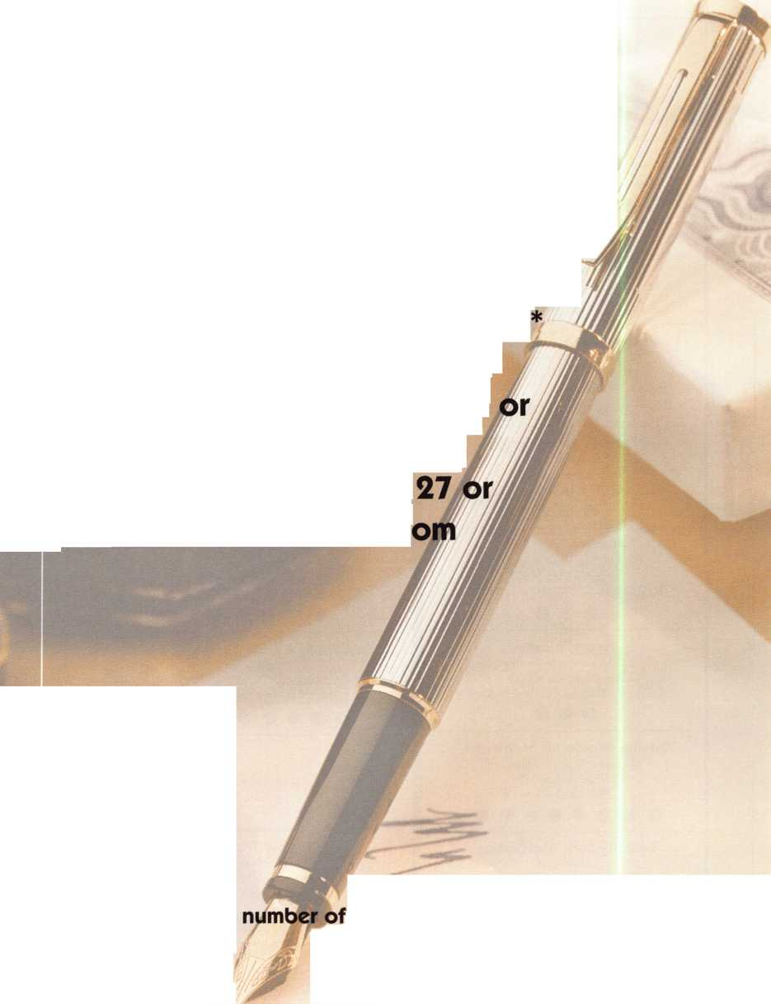

Keynotes

Authors



BL J| *Sal Dulcamaro,* CML, has been in the locksmith business for over 25 years. He is the president of All Pro Security, Inc. in

^— * Michigan and has been an ALOA member

for 18 years. A past president of the Locksmith Security Association of Michigan. Sal currently serves as editor of the association newsletter. He was named “Keynotes Author of the Year” for 1996 and 1997. He is also a contributing editor for Keynotes.

*B*

*Tim McMullen* oversees legislative affairs  
for ALOA. He is a graduate of the District  
of Columbia School of Law and has an  
extensive background in legislative work.

*Tom Seroogy* is a member of ALOA and a certified ACE instructor who specializes in automotive locksmithing and access control. He is also a sales represenative with an extensive background in locksmithing and sales. He is the former managing editor of The National Locksmith Automobile Association (NLAA) and director of Crime Prevention Magazine.

*John Whatley* is a retired Army officer and a former newspaper publisher. He is a freelance writer living in Atlanta, Georgia. He has published four books and over 200 articles in magazines and newspapers. He is also the edit or!publisher of [www.TheNativeAmericanJournal.com](http://www.TheNativeAmericanJournal.com).

|  |  |
| --- | --- |
| Keynotes Advertisers Index | |
| Advertisers | Page |
| Aabie | 32 |
| ALOA 2001 | IBC |
| Hickok | IFC |
| Intralock | 22 |
| Key Sales | 12 |
| Marray | 15 |
| MasterLink Security Products | 8 |
| National Locksmith | BC |
| SAFETECH 2001 | 11 |
| Safe Tech Reference Manual | 29 |
| Security Lock Company | 33 |
| Stam Insight | 1 |
| Strattec | 7 |
| Tech Train Productions | 27 |
| Turn 10 | 35 |

November 2000

Keynotes

Discover What You Might Miss

The Security Expo saw an 11 percent increase in 2000 and  
numerous booths have already been sold for 2001. Plan now  
to catch those great bargains and new products.

Another good reason to attend ALOA 2001 is the site itself, Baltimore. The charming city by the Bay has many historic sites, world-renowned art institutions, professional and collegiate sports teams, shopping areas and many more attractions and sights to see.

So plan now to attend ALOA 2001 in Baltimore. Discover what you’ve been missing. Call 800-532-2562 for more information.

We look forward to seeing you soon!!

The year 2000 is almost over, so let’s look ahead to 2001.

ot just the year, but the ALOA 2001 Convention and

Security Expo, July 15-22, 2000 in Baltimore. This event  
promises to be bigger and better than ALOA 2000 in Las  
Vegas. So, if you missed Las Vegas you don’t want to miss  
Baltimore.

Education is the foundation for every ALOA Show and 2001  
is no different. The education department has made the call

r presentations and the response has been great. Plan now

to attend so you can take advantage of the quality education  
that the ACE Program has to offer.

The ALOA Scholarship Foundation started working toward  
2001 at the Las Vegas show, so expect great things to  
happen. The foundation awarded 25 scholarships to ALOA  
2000, so everyone should take advantage of this opportunity  
by completing a scholarship application for 2001. You never  
know who that next recipient might be. It could be you!



begin with one.

to begin a new CclTGGT in locksmithing,

develop a new business strategy, or advance your skills in lock technology

there's only OP10 place you need to go.



ALOA 2001

(Z

E

OJ

CM

VO

VO

Cs|

rsi

m

vo

•

o

o

00

become one with your industry july 15-22

at baltimore convention center

(Z

U

C

o

4->

(Z

E

o

CD

j_

O

baltimore, maryland

O

.HfwCw.

PndJggS.

B'« lgE.

I ’,v‘'

1

M00-7T51 6*?«&idi WQXOtt

VwHicW

iQnlatlP?

r^n.-ov,

KyBto**

*Do you own other  
rode software?*

C*s*S$ W*

a*m

OiAk

CfClWCH

|Ut«Cod«

iFrafro^

U-1

Now *take $200.00 off*

**loaded with new features and hundred:  
of new code series, including GM!**

**InstaCode 2000**

from The National Locksmith^

the cost of the best code software... InstaCode 2000! Simply send in your order  
with proof of ownership of another code program.*

You've heard about InstaCode 2000. Now it's time to experience the difference!

***\* Qualifying proof that you own other code software: you may send a photocopy of your invoice, a photocopy of the front page of your owners manual, or a photocopy of your install disk. This offer expires on 12/31/00.***

Select

payment

method:

Card #:

* Check □ VISA □ MasterCard
* Discover □ American Express

Exp. Date: _

Signature (required):

Format: ***CD-ROM***

City:

State/Zip:

Phone:

E-mail (optional):

Orders outside the continental US include $20 for shipping and handling.  
All orders must be paid in US funds. We sell within North America only.

Copy or clip this coupon and send with payment to:

The National Locksmith, RO. Box 77-97592  
Chicago, IL 60678-7592

* ***Yes!*** Send me the InstaCode 2000 software. **I've** Name:

enclosed **$695 + $5** for shipping and handling.

Shop Name:

* ***Yes!*** I own other code software (proof enclosed).

I've enclosed **$495 + $5** for shipping and handling.Address (no po boxes):

System Requirements: Windows 95 or later, 486 or better, 20 MB of available hard drive space, minimum  
16 MB of RAM, Windows supported printer, mouse or pointing device.

OID: 10/C

